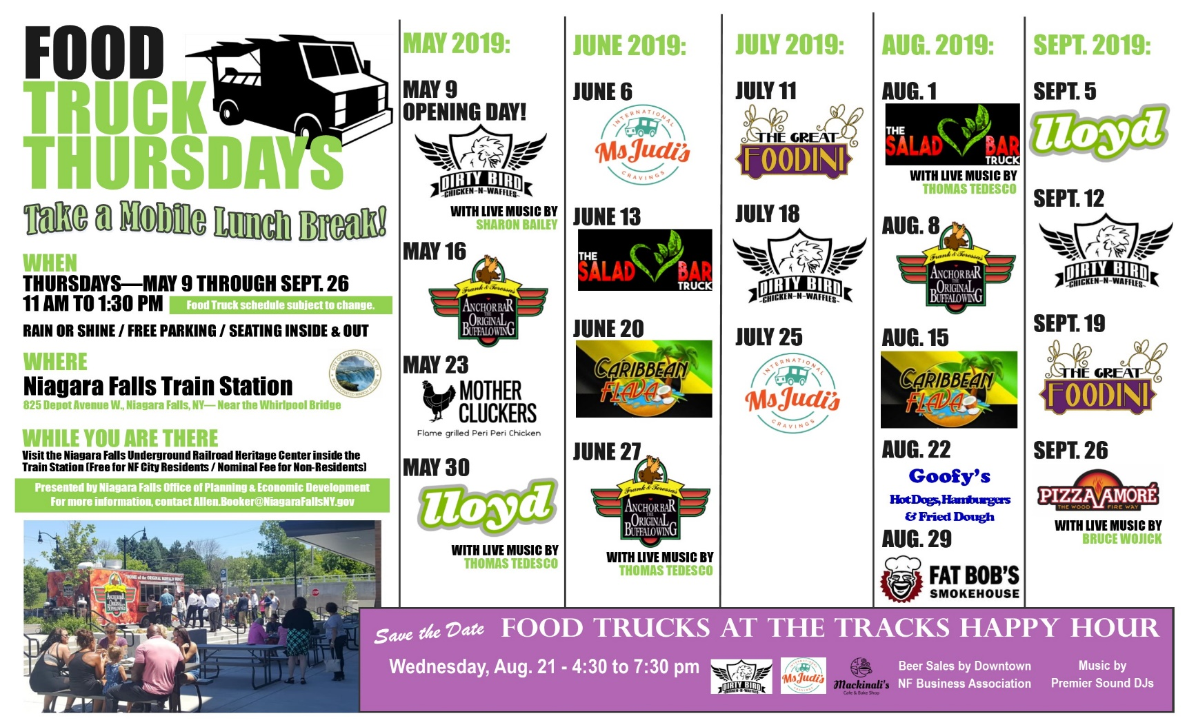
Come Join Us for Some Great Food and Live Music!

- July 23- Steaksters (featuring Tedesco Knows Best)

- July 30- Dirty Bird & LuGia’s on Wheels (featuring Marsha McWilson)

- August 6- Steaksters (Featuring-TBA)

- August 13- Fat Bobs (featuring Sharon Bailey)

- August 20- Pizza Amore (featuring Tedesco Knows Best)

- August 27th- J&L BBQ & LuGia’s on Wheels (featuring Bruce Wojick)

- September 3rd- Caribbean Flava (featuring Sharon Bailey)

- September 10th- J&L BBQ (featuring- TBA)

Guests are asked to follow Covid-19 safety guidelines, which will be posted at the event.

Food Truck Thursdays is being presented by the Niagara Falls Office of Planning and Economic Development. The series is sponsored by Blue Cardinal Capital and Rainbow Air Inc. Scenic Tours.

Subject to change

