Camden County Board of Commissioners
Regular Meeting
June 7, 2010
6:00 P.M. – Closed Session
7:00 P.M. – Regular Meeting
Historic Courtroom, Courthouse Complex
Camden, North Carolina

MINUTES

The regular meeting of the Camden County Board of Commissioners was held on Monday June 7, 2010 at 7:00 p.m., with a closed session held at 6:00 p.m. in the Historic Courtroom, Camden, North Carolina. The following Commissioners were present:

Chairman Phil Faison, Vice-Chairman Sandra J. Duckwall,
Commissioners Melvin Jeralds, Michael McLain, and Garry Meiggs.

Also attending were County Manager Randell Woodruff, Associate County Attorney Courtney Hull, and Clerk to the Board Ava Gurganus. Present for purposes of making a presentation or providing supporting information for agenda items were the following persons: Mr. Andy Lovingood & Mr. Dave Richmond of McGill & Associates; Clarann Mansfield, Camden County Finance Officer; Carolyn Morris of the Albemarle Commission; Peggy Kight, Camden County Register of Deeds.

Commissioner Melvin Jeralds made a motion to go into closed session at 6:00 p.m. pursuant to G.S. 143-318.11(a)(3) for the purpose of a Joint Meeting with the Board of Education. The motion passed 5-0, with Chairman Commissioner Phil Faison, Vice-Chairman Commissioner Sandra J. Duckwall, Commissioners Melvin Jeralds, Garry Meiggs, and Michael McLain voting aye; no Commissioner voting no; no Commissioner absent; and no Commissioner not voting.

Closed Session Joint Meeting with Board of Education Pursuant to
G.S. 143-318.11(a)(3) - Consultation with Attorney

The Commissioners entered closed session at 6:00 p.m.

Present in closed session were Camden County Commissioners: Chairman Phil Faison, Vice-Chairman Sandra J. Duckwall, Commissioners Melvin Jeralds, Michael McLain, and Garry Meiggs.

Present from Camden County Board of Education were: Chairman Terri Faison, Vice-Chairman Dan Moore, Members Wayne White, Chris Wilson, and Christian Overton, Camden County School Superintendent Dr. John Dunn, and Attorney Brady Wells.

Also attending were County Manager Randell Woodruff, County Attorney Courtney Hull, and Clerk to the Board Ava Gurganus.

Commissioner Melvin Jeralds made a motion to come out of closed session. The motion passed 5-0, with Chairman Commissioner Phil Faison, Vice-Chairman Commissioner Sandra J. Duckwall, Commissioners Melvin Jeralds, Garry Meiggs, and Michael McLain voting aye; no Commissioner voting no; no Commissioner absent; and no Commissioner not voting.

Invocation and Pledge of Allegiance

The Commissioners re-entered regular session at 7:00 p.m.

Commissioner Garry Meiggs gave the invocation and led those present in the Pledge of Allegiance.

Public Comments

The following public comments were heard:

Terry Rose of Shiloh Township, NC spoke on a personnel issue and made a plea to the Board for help.

Buddy Tucker of Camden Township, NC spoke in regards to the Memorial Day services that were held at the Courthouse:
- No flag could be found upon their arrival to the Courthouse, they had to send someone to Elizabeth City to get a flag before the ceremony could commence
- There was an apparent lack of participation, only 10 people showed up, among those 10 were 1 Commissioner and 1 Deputy Sheriff.

Consideration of Agenda

Chairman Commissioner Phil Faison asked if there were any changes to the agenda. County Manager Randell Woodruff asked to amend the agenda to add ‘CDBG Scattered Site Housing Program’, which was inadvertently left off, under Public Hearings as Item # 4.

Commissioner Michael McLain made a motion to Approve the Agenda as Amended. The motion passed 5-0, with Chairman Commissioner Phil Faison, Vice-Chairman Commissioner Sandra J. Duckwall, Commissioners Melvin Jeralds, Garry Meiggs, and Michael McLain voting aye; no Commissioner voting no; no Commissioner absent; and no Commissioner not voting.

Old Business

Crooked Creek Project

Dan Porter, Planning Director, gave a brief introduction to this agenda item:
- Trying to get grant funds every grant cycle to make improvements to the Crooked Creek access point to the North River, which is right off of Garrington Road
- Applied for CAMA grants, wildlife grants, all of which have been denied due to lack of funding
- Dan Porter and Randell Woodruff met with wildlife engineers who offered to do some of the improvements that were part of the projects
- A project description is included in the Board packet for the June 7 2010 meeting
  - It is from one of the grant applications which was submitted
  - It shows the overall budget of $82,350 with the Wildlife Commission carrying the majority of that load of $22,650.
  - Wildlife Commission will do some but not all of the work for Camden.
- Only way Wildlife Commission will do the work for Camden County is if Camden County gets the permits and permissions to go on the land.
- What is being asked is approval of funding to get the wetland delineation maps and permits
  - Wetland delineation and mapping will cost approximately $2100
  - Permits will cost approximately $1300

Commissioner Melvin Jeralds asked Mr. Porter if any arrangements had been made to acquire the land from the property owner for it to be used as the parking lot as of yet. Mr. Porter responded that he had spoken with the property owner’s (Mr. Staples) son and that talks are underway to make those arrangements. Mr. Porter further stated that the last time that a grant was attempted, Mr. Staples was willing to provide a long term lease, but that the grant fell through and the agreement between Camden and Mr. Staples was not in writing. Mr. Porter said that no work would be done, no money spent, on this until Mr. Staples had given his approval and some kind of arrangement had been made with him. All that Mr. Porter is attempting at this point is to ‘get all his ducks in a row’ so that when he goes to speak with Mr. Staples he can say with some measure of certainty that this time will be different. Mr. Porter’s effort’s before the Board here tonight are to get all his approvals so that he can go to Mr. Staples and say ‘we’re ready, we need a lease now’.
Commissioner Michael McLain asked how many applications have actually been submitted in an effort to accomplish this project with Mr. Staples. Mr. Porter responded that there have been 3 CAMA, and 1 Wildlife applications.

Mr. Porter listed the problems with the applications:
- The first application, Mr. Staples was not willing to give us access to the property
- The second application Mr. Staples was willing to give us access to the property, but the commission didn’t like the lease rate he had
- The third application, the CAMA funding was a supplemental funding round and they didn’t want to fund this project in a secondary round
- The fourth application, we have never had it in writing from Mr. Staples but we have had an agreement on 2 or 3 different occasions we just were not able to follow through when the funding fell through.

Commissioner Michael McLain asked for clarification of what was being asked of the Board. He stated what he thought was being asked: “Approval of spending $2100 and $1300 but only contingent upon prior approval of a lease agreement between the county and Mr. Staples. If that doesn’t come through, then there will be no expenditure of funs.” Commissioner McLain asked if this is correct. Mr. Porter responded that it was correct, and added that a lease agreement would be brought before the Board for their approval before proceeding further.

Commissioner Michael McLain asked if Mr. Porter anticipated any problems securing the lease agreement. Mr. Porter responded that his last conversation with Mr. Staples’ son was a positive conversation, and that the feeling was that it was ‘a do-able thing’.

Commissioner Michael McLain asked if Mr. Porter knew what the lease rate would be. Mr. Porter stated that last time a verbal agreement was made, the lease rate was $500/year.

Commissioner Sandra Duckwall asked if Mr. Porter felt that Mr. Staples may be ready to sign. Mr. Porter responded that he thinks Mr. Staples is very close to that point.

Chairman Commissioner Phil Faison asked for clarification that no money would be spent if Mr. Staples does not agree to the lease. Mr. Porter responded that is correct.

Commissioner Michael McLain asked for clarification as to exactly what is being asked of the Board: “Are you looking for a motion that should we get a lease and should the lease be approved, you can do the map delineation (approximate cost $2100), and apply for the permits (approximate cost $1300), and all that is contingent upon an acceptable lease agreement being reached between the county and Mr. Staples.”

Mr. Porter responded to Commissioner McLain’s clarification question stating that it was correct.

Commissioner Michael McLain made a motion to “Let Mr. Porter enter into lease negotiations with Mr. Staples; Then bring the lease agreement back to the Board of Commissioners, and upon approval of the lease, Mr. Porter can do the map delineation and apply for the permits.” The motion passed 5-0, with Chairman Commissioner Phil Faison, Vice-Chairman Commissioner Sandra J. Duckwall, Commissioners Melvin Jeralds, Garry Meiggs, and Michael McLain voting aye; no Commissioner voting no; no Commissioner absent; and no Commissioner not voting.

IDF - Utility Account - Grant Award - $500,000 - Grant #U-401 - Camden County Eco Industrial Park and Grant Funding Approval

Mr. Andy Lovingood of McGill Associates was present at the meeting and spoke in reference to this agenda item.
- This is a resolution from the NC Department of Commerce
  - NC Industrial Development Fund Utility Account Project Assistance in the amount of $500,000 for transportation improvements at the Eco Park.
  - Coupled with NCDOT Grant of $425,000
  - Puts County closer to project funding goal needed for the project
Commissioner Michael McLain asked if this grant continued the road improvements in the park. Mr. Lovingood responded that it did.

Vice Chairman Commissioner Sandra Duckwall made a motion to “Accept the grant and authorize the chairman to sign the necessary documents.” The motion passed 5-0, with Chairman Commissioner Phil Faison, Vice-Chairman Commissioner Sandra J. Duckwall, Commissioners Melvin Jeralds, Garry Meiggs, and Michael McLain voting aye; no Commissioner voting no; no Commissioner absent; and no Commissioner not voting.

Budget Amendment - South Camden Volunteer Fire Department - Shiloh Station 11 - Site Preparation

Clarann Mansfield gave a brief introduction to this agenda item:
- This is for approval of the low bid for the site work to be done for the new fire station in Shiloh and have the Commissioners sign the appropriate papers.
- The Fire Commissioners have signed off on all the paperwork they needed to sign off on.
- Fire Commissioners have met and approved the advertising for the bids, etc.

Commissioner Garry Meiggs made a motion to Approve ‘Budget Amendment - South Camden Volunteer Fire Department - Shiloh Station 11 - Site Preparation’. The motion passed 5-0, with Chairman Commissioner Phil Faison, Vice-Chairman Commissioner Sandra J. Duckwall, Commissioners Melvin Jeralds, Garry Meiggs, and Michael McLain voting aye; no Commissioner voting no; no Commissioner absent; and no Commissioner not voting.

Correction to May 3, 2010 Minutes

Commissioner Michael McLain made a motion to Approve the ‘Correction to May 3, 2010 Minutes’. The motion passed 5-0, with Chairman Commissioner Phil Faison, Vice-Chairman Commissioner Sandra J. Duckwall, Commissioners Melvin Jeralds, Garry Meiggs, and Michael McLain voting aye; no Commissioner voting no; no Commissioner absent; and no Commissioner not voting.

Consolidation Agreement - East Carolina Behavioral Health

Chairman Commissioner Phil Faison opened discussion of this agenda item by stating that there are some issues with the land appropriation section of the contract. Page 3, Section 5, Paragraph (a) of the Consolidation Agreement deals with a question regarding transfer of property by general warranty deed.

Randell Woodruff, County Manager, stated that he had been in contact with Bobby Outten, Dare County Manager, who is investigating the possibility of several area County Managers attending the next ECBH Board Meeting (middle of June) so that land issue concerns dealing with transfer of property can be addressed. Some of those issues are below:

- Camden Officials do not feel that these buildings should be taken away and transferred over to ECBH
- Camden and Perquimans were the only 2 counties that had buildings that were owned by Albemarle Mental Health
- State Director of Mental Health told Camden County Manager that transferring full ownership of the buildings to the counties was fine with the State.
- As of this late date, ECBH Board has adopted this contract that requires all of the assets in the building to be transferred to ECBH
- Perquimans County is voting on this same matter tonight
  - Bobby Darden, Perquimans County Manager, indicated he felt his board has the same concerns
  - Perquimans is in a little different situation than Camden in that they contributed the land for the building in Perquimans to be constructed upon, whereas Camden didn’t
    - Camden’s building was entirely paid for and financed by Albemarle Mental Health
- County Manager Randell Woodruff feels that should the building be transferred to Camden, it would still allow ECBH to use it for their facility here in Camden, but it would benefit the County by allowing the County to retain ownership of 2/3 of that complex as opposed to 1/3 which is what is currently owned at the Camden Medical Park.

Mr. Woodruff suggested to the Board that they could consider holding this matter over until the June 21st Commissioners Meeting, so that he could attend the ECBH Board meeting and express Camden’s views on the matter and then report back to the Camden Board of Commissioners.

On the matter of continuing benefits for the former Albemarle Mental Health and Tideland Mental Health Employees (included in this complex issue), Vice Chairman Commissioner Sandra Duckwall asked whether the state is holding money to go toward the benefits of these former employees. Mr. Woodruff stated that the State is holding approximately $600,000 for that purpose, and that it would be used to pay retiree health care benefits for a period of about 5 years. Commissioner Duckwall further asked what happens when the money runs out. Mr. Woodruff responded that there are differing legal viewpoints:
- Some say that the 10 counties including Camden County will have the legal obligation to continue providing retiree health care benefits for those 19 employees forever, for the rest of their lives
- Others say that we could break away and say that we did not have an obligation to continue to honor that agreement
- There may need to be an outside legal opinion given on the matter to clarify the matter
- We’ve heard from several attorneys, managers that are attorneys, and they’ve expressed opinions that we will have that obligation ongoing in the future after the funds are used up in 4 or 5 years

Commissioner Michael McLain asked Mr. Woodruff if he knew of any other claims against Albemarle Mental Health. Mr. Woodruff responded that he did not know of any.

Vice Chairman Commissioner Sandra Duckwall asked Mr. Woodruff if he had a list of all of the assets that were in the Albemarle Mental Health building. Mr. Woodruff stated he had a list at the county offices, and it contained things like chairs, desks, furniture, etc.

Vice Chairman Commissioner Sandra Duckwall asked Mr. Woodruff what property had been transferred to Pasquotank. Mr. Woodruff responded that there were several offices in Elizabeth City, in Pasquotank that were fully furnished with furniture and etc, presumably that furniture has been transferred. Mr. Woodruff also stated that the State Director of Mental Health had said that no furniture or equipment was to be returned to the state, it was to be disposed of in a manner determined by the counties (which meant it could be transferred to the counties for their own use) in which said furniture or equipment was located, the same held true for vehicles. The understanding now is that all vehicles involved have been transferred.

Commissioner Michael McLain asked for a breakdown of the 19 employees who would be receiving benefits, the list before the Board only shows 9 employees. County Manager Randell Woodruff responded to this saying that there are 19 total employees, the list before the Board is the list of former Tideland employees, who were brought over and into Albemarle Mental Health when the 2 entities merged into a new Albemarle Mental Health. When the merger occurred, Tideland money in the amount of approximately $816,000 was brought over from Tideland and merged with Albemarle Mental Health and then misappropriated.
Commissioner McLain further stated that he would still like to see the entire break down of the 19 employees, who came from where, etc. Mr. Woodruff stated he could get that breakdown for the next meeting. Mr. Woodruff went on to say that he was told some time ago that the former Director of Albemarle Mental Health was not among the list of retirees to be receiving benefits, however at a meeting in May he received an update in which information was disclosed wherein he found out that was not the case, the former Director of Albemarle Mental Health is among those to receive health care benefits.

Vice Chairman Commissioner Sandra Duckwall stated that a resolution was passed a few months ago that addressed supporting benefits for the former employees of Albemarle Mental Health. She questioned whether resolution should stand or be reconsidered. Her question went unanswered by the Board.

County Manager Randell Woodruff stated that the resolution was sent to the General Assembly along with a request for them to consider including the 19 former Albemarle Mental Health employees in the State Employees Heath Plan which would lift the burden from the counties. Since then, he has heard back from Senator Basnight and Representative Owens and they have said that is not going to work to handle it that way. Mr. Woodruff further stated that the resolution did say that the county supported trying to do something to help those 19 employees keep their health coverage, but it did not intend to provide support or coverage to the person who contributed to the downfall of that agency.

Chairman Commissioner Phil Faison stated the following “I hope I speak for the Board when I say this… We need to clear up this disposition of real property before we move any further.”

County Manager Randell Woodruff responded saying that his opinion is that plans to attend the ECBH Board Meeting need to be made, where they (ECBH) will have their complete board present (of which Chairman Faison serves on), and perhaps take a few other commissioners. This way Camden County’s concerns can be communicated to the ECBH Board. Mr. Woodruff asked the Board if he could communicate to Ms. Futrell at ECBH that no action was taken at this meeting and that representatives from Camden County would like to attend the next ECBH meeting. Chairman Faison agreed.

NO ACTION TAKEN ON THIS AGENDA ITEM, TABLED TO NEXT MEETING PENDING OUTCOME OF MID JUNE ECBH BOARD MEETING

Public Hearings

Commissioner Michael McLain made a motion to enter into public hearings for the purpose of hearing ordinance number 2010-06-01 and Resolutions 2010-06-02, and 2010-06-03. The motion passed 5-0, with Chairman Commissioner Phil Faison, Vice-Chairman Commissioner Sandra J. Duckwall, Commissioners Melvin Jeralds, Garry Meiggs, and Michael McLain voting aye; no Commissioner voting no; no Commissioner absent; and no Commissioner not voting.

County Manager Randell Woodruff stated that this is the budget resolution for the Fiscal Year 2010-2011 County Budget.

Chairman Commissioner Phil Faison asked if there were any comments or questions from the Board or public regarding these issues. Not hearing any, he called for a motion to exit public hearing.

Vice Chairman Commissioner Sandra Duckwall made a motion to exit public hearing on these issues. The motion passed 5-0, with Chairman Commissioner Phil Faison, Vice-Chairman Commissioner Sandra J. Duckwall, Commissioners Melvin Jeralds, Garry Meiggs, and Michael McLain voting aye; no Commissioner voting no; no Commissioner absent; and no Commissioner not voting.

Chairman Commissioner Phil Faison stated that at this time each of the items would be looked at separately, and to consider a motion to approve or not to approve.
County Manager Randell Woodruff reminded Chairman Faison about Public Hearing #4, CDBG Scattered Site Housing which was added at the beginning of the meeting and amended to the agenda.

Commissioner Melvin Jeralds made a motion to re-enter into public hearing for the purpose of hearing CDBG Scattered Site Housing Program. The motion passed 5-0, with Chairman Commissioner Phil Faison, Vice-Chairman Commissioner Sandra J. Duckwall, Commissioners Melvin Jeralds, Garry Meiggs, and Michael McLain voting aye; no Commissioner voting no; no Commissioner absent; and no Commissioner not voting.

Mr. Dan Porter, Director of Planning, stated that the county is currently operating a Community Development Block Grant Scattered Site Housing Program, which is being administered through the Albemarle Commission. Camden is nearing completion of replacement of 3 housing units under that program. Ms. Carolyn Morris is at the meeting to give a report to the Board and answer any questions or comments from the Board and / or public.

Vice Chairman Commissioner Sandra Duckwall raised a question as to the advertising of the public hearing for the CDBG Scattered Site Housing Program Public Hearing. She did not think that it had been advertised. Mr. Porter responded saying that it had been advertised, that he had made a mistake and had not gotten the documents to the clerk in time to include on the agenda. Vice Chairman Duckwall then asked the clerk regarding the advertising, to which the clerk responded that she was unaware of any advertising having been done for this item. Mr. Porter responded, saying that the advertisement was sent to The Daily Advance, he added that Ms. Morris will address the issue. Vice Chairman Duckwall was satisfied with that and said that Ms. Morris has the question.

At this time, Ms. Carolyn Morris came to the podium. She addressed the advertisement issue first. Advertisement was placed in the May 26th edition of the Daily Advance, at a cost of $211.84, and is one of the final bills the Albemarle Commission has to pay in relation to this grant.

Chairman Phil Faison asked her if she had a copy of the bill. (no response)

Ms. Morris continued, saying that they were scheduled to clear 3 dilapidated housing units for the $400,000 grant and replace the houses on the same lots. Two of the houses are already complete and there is a 3rd one, the house is there but there are some final things to be done. A total of $391,005.16 was spent whether it was for demolition, temporary relocation, homeowners insurance, the cost of the housing, surveys, septic tanks, etc. The grant doesn’t have to be closed out until February or March 2011 so progress on this is way ahead of schedule. Ms. Morris will be providing the Board with some reports on this at a later date, she mentioned a desire to have all the grant funds spent in the current fiscal year without any carryover for the county to the next cycle. She mentioned also a desire to have all the bills paid by June 17th, the DCA, the Division of Community Assistance, closes their books on June 24th and she wants to close out the county’s books on this a week or so earlier if possible.

Chairman Commissioner Phil Faison asked if there were any comments from the public or from the Board for Ms. Morris on this.

Commissioner Michael McLain asked when the next cycle of these grants will begin, he has had some inquiries. Ms. Morris responded the next grant cycle will begin in 2011

Mr. Dan Porter, Director of Planning, commented that Ms. Morris picked up this 3-year project in the middle of it. She had to re-do a lot of the work, and is closing out the project almost an entire year early. She should be commended. She did a great job.

At this time, Chairman Commissioner Phil Faison entertained a motion to exit public hearing. Commissioner Michael McLain made a motion to exit public hearing on this issue. The motion passed 5-0, with Chairman Commissioner Phil Faison, Vice-Chairman Commissioner Sandra J. Duckwall, Commissioners Melvin Jeralds, Garry Meiggs, and Michael McLain voting aye; no Commissioner voting no; no Commissioner absent; and no Commissioner not voting.

Consideration of Items Heard at Public Hearing

Consideration of Ordinance 2010-06-01

Commissioner Melvin Jeralds asked Chairman Commissioner Phil Faison if there were still some issues in this ordinance that haven’t been resolved, based on waiting for what Pasquotank County is going to do. Chairman Faison stated that he was correct. Commissioner Jeralds stated that he feels the Board should wait until final figures are in so that knowledge of what exactly the budget is going to be can be taken into consideration prior to approving this ordinance.

Chairman Faison asked if that would apply to all three, the ordinance, and the two resolutions. Commissioner Jeralds responded yes. Chairman Faison agreed, and asked if any other Board Member had a comment on the matter.

Commissioner Michael McLain asked Ms. Clarann Mansfield if she had heard anything out of Pasquotank in regards to the Library, COA, or anything else that might impact Camden County’s budget. Ms. Mansfield responded no.

Chairman Commissioner Phil Faison, speaking for the Board, stated that this needed to be tabled until final figures could be obtained from the other agencies which have an impact on Camden County’s budget, so that the Board would have knowledge of what the budget figures are prior to approving the ordinance. The other Commissioners agreed with him, and he instructed the clerk to place it on the next meeting’s agenda, which would be June 21, 2010. He further instructed Randell Woodruff, County Manager, to make contact with the agencies wherein figures are needed and obtain those needed figures.

NO ACTION ON THIS AGENDA ITEM, TABLED TILL NEXT MEETING PENDING FIGURES FROM OTHER AGENCIES, AND A FINAL BUDGET FIGURE

Consent Agenda

Commissioner Michael McLain made a motion to Approve the Consent Agenda. The motion passed 5-0, with Chairman Commissioner Phil Faison, Vice-Chairman Commissioner Sandra J. Duckwall, Commissioners Melvin Jeralds, Garry Meiggs, and Michael McLain voting aye; no Commissioner voting no; no Commissioner absent; and no Commissioner not voting.
Consent Agenda

A. Draft Minutes - May 17, 2010 Regular Meeting
May 25, 2010 - Budget Work Session
May 27, 2010 - Budget Work Session

B. Authorization to Collect - February Renewals

C. Tax Releases, Pick Ups, & Refunds

D. Tax Collection Report

E. Letter of Thanks to Kenny Simmons - Parks & Rec Advisory Board

F. North Carolina Approved EMS System

G. Budget Amendments 2009-10-BA048 through 2009-10-BA053

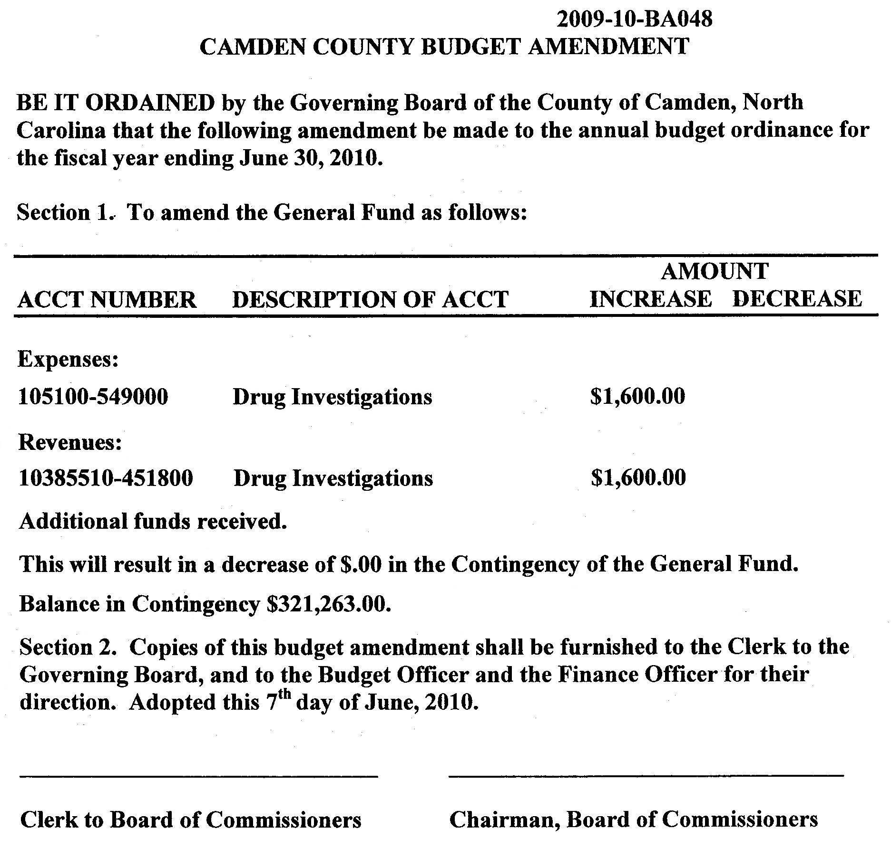

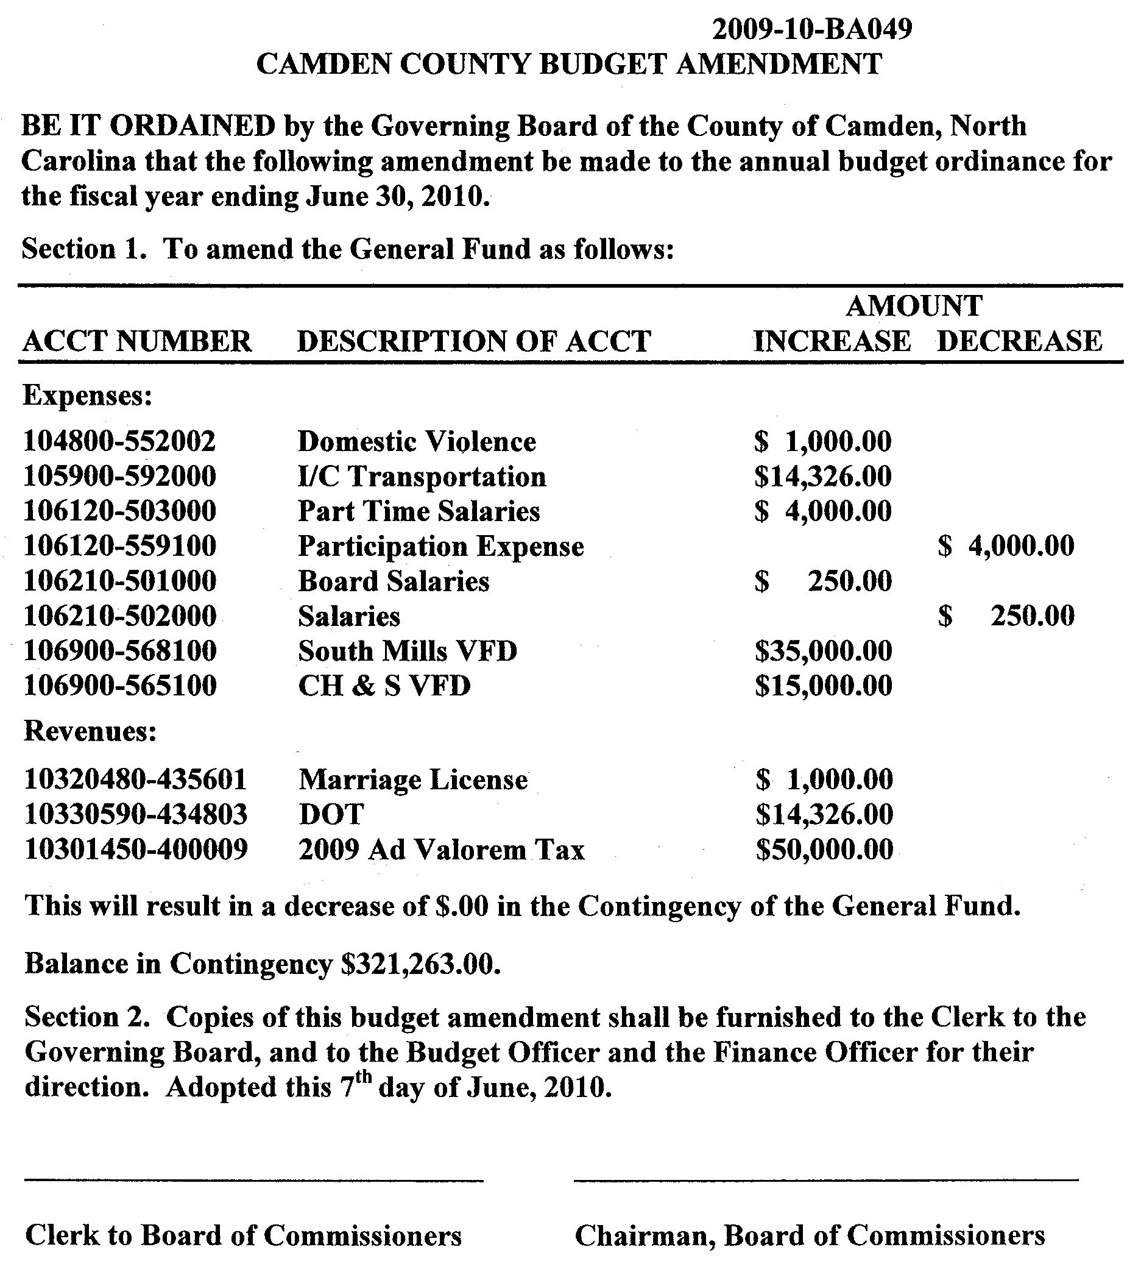

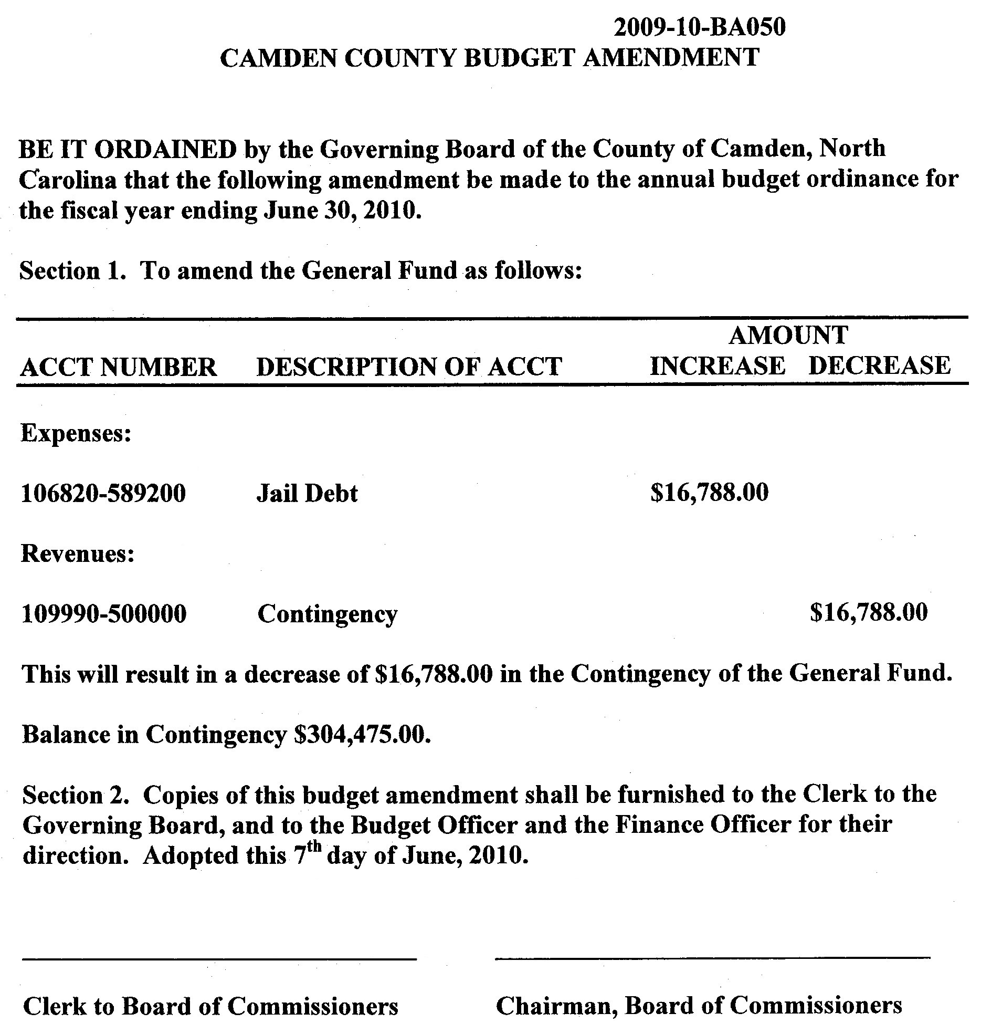

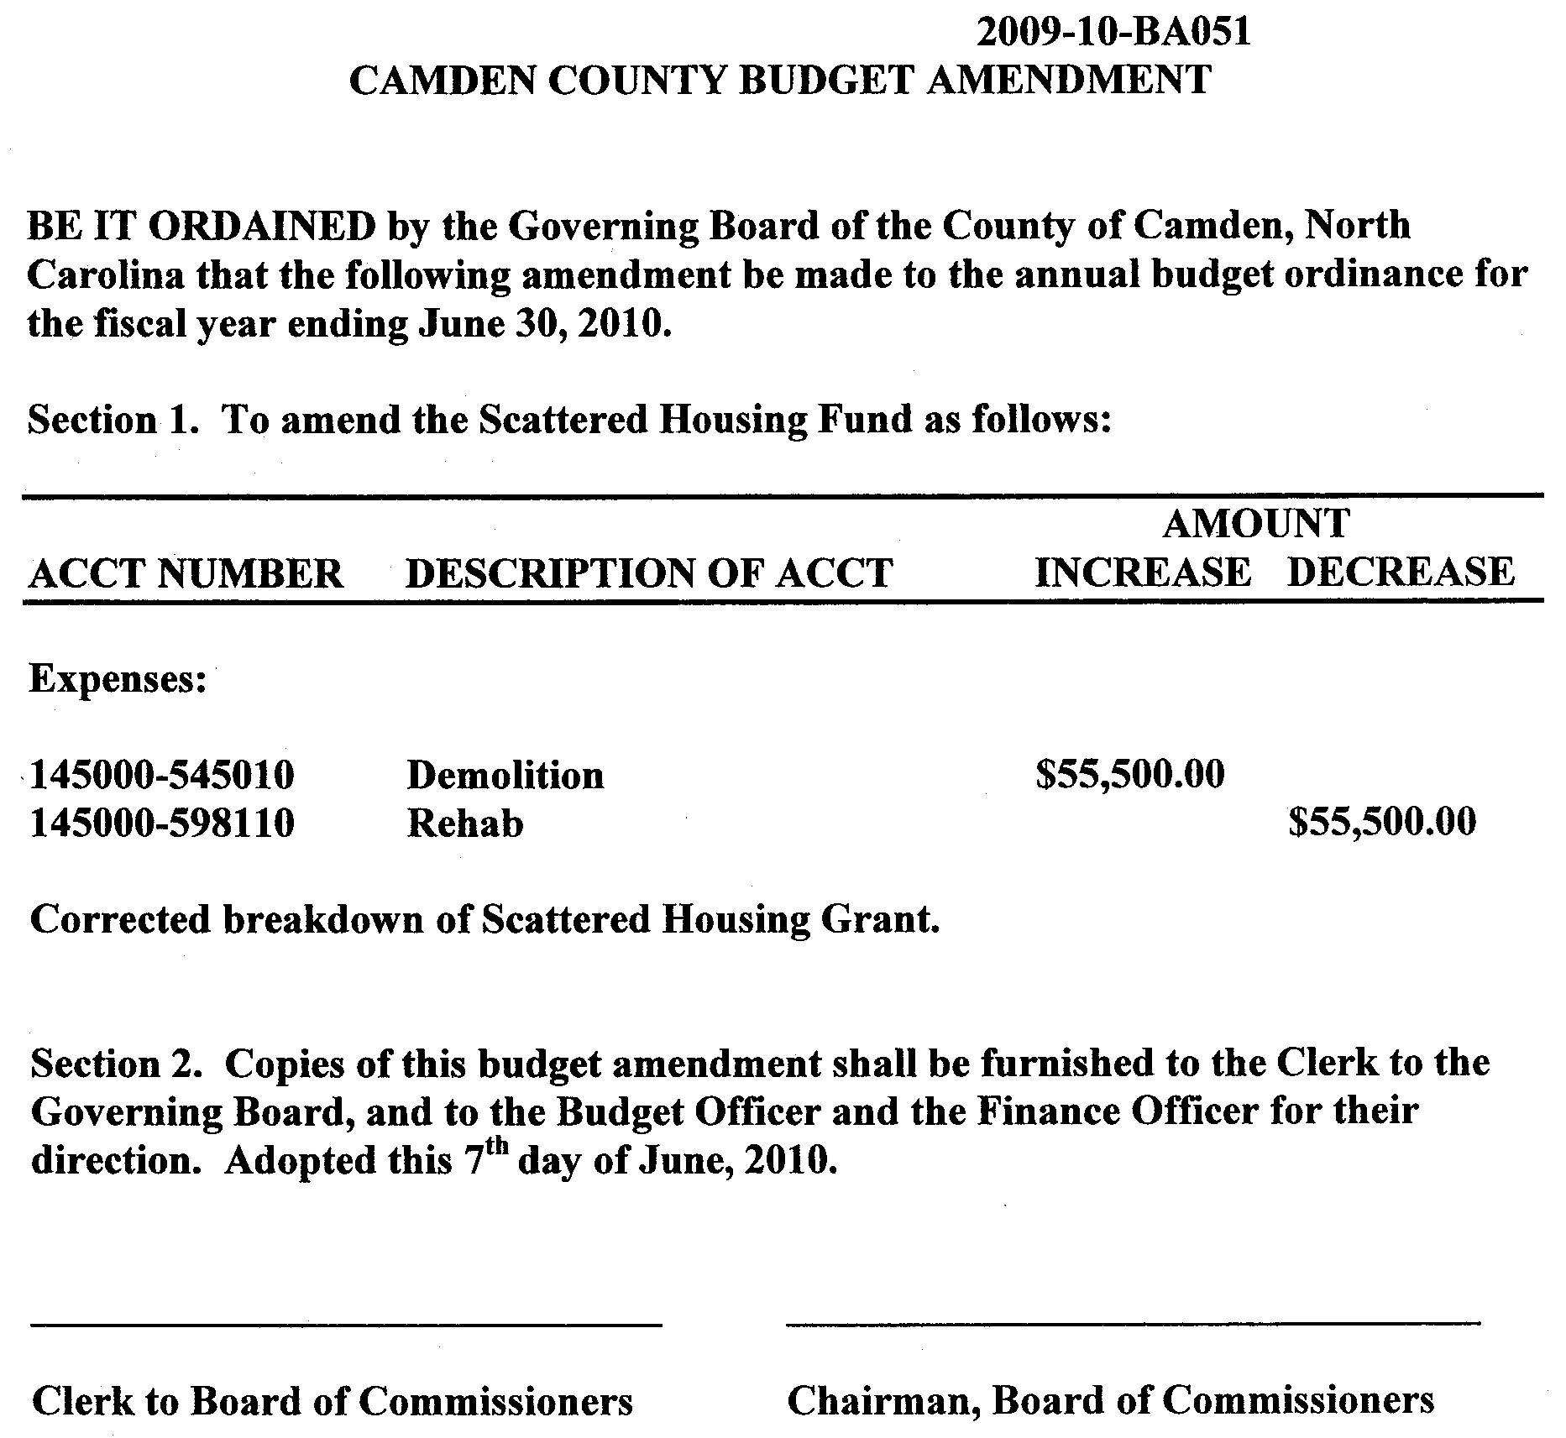

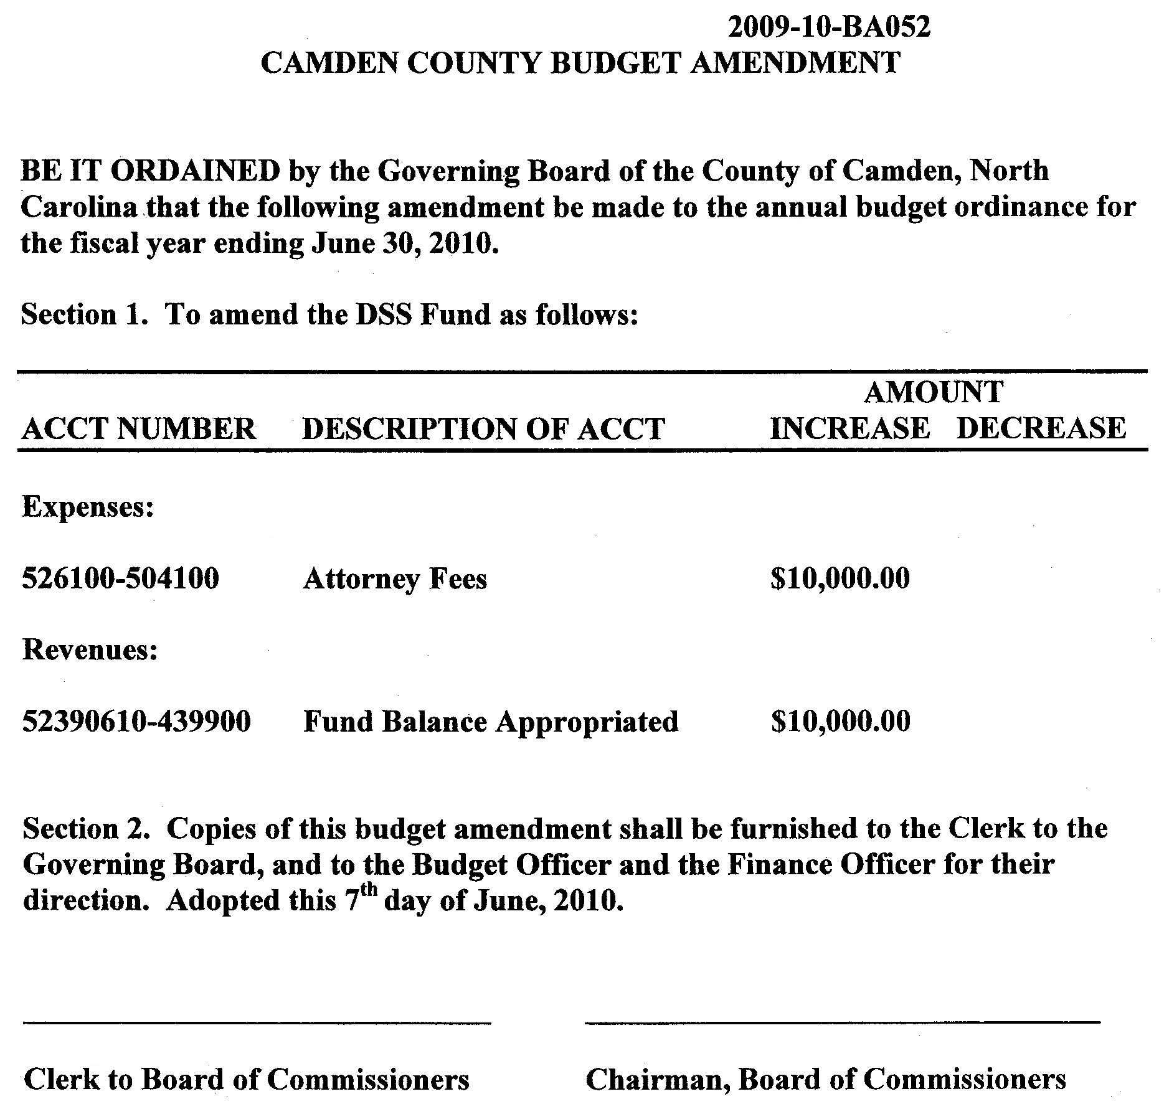

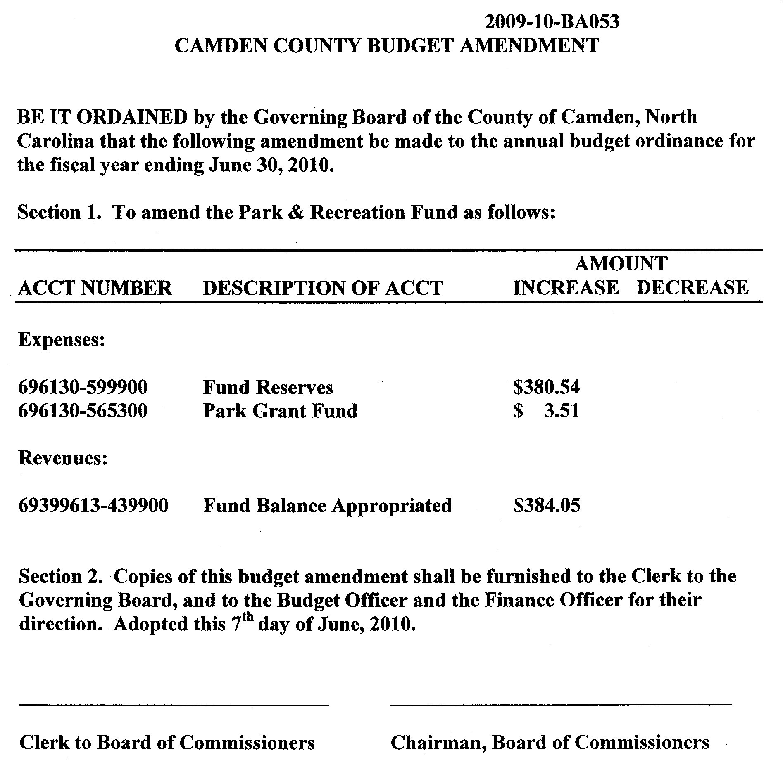

H. Set Public Hearing for Capital Improvement Plan for June 21, 2010

I. Letters of Thanks to Senators Hagan and Burr - Mandated Public Safety Employee Collective Bargaining

New Business

Tyler Technologies Agreement - Register of Deeds

Randell Woodruff, County Manager, yielded the floor to Peggy Kight, Register of Deeds, who described this agenda item:

- This is the same agreement signed every year for the past 11 years
  - Only difference is Tyler Tech is no longer including the supplies and maintenance of the hardware

Commissioner Michael McLain asked if this contract / agreement was sent to the county attorney for review. Ms. Kight responded that it had, and there was a letter from John Morrison, County Attorney, included in the board packet.

Commissioner Garry Meiggs made a motion to Approve the Tyler Technologies Agreement for the Register of Deeds. The motion passed 5-0, with Chairman Commissioner Phil Faison, Vice-Chairman Commissioner Sandra J. Duckwall, Commissioners Melvin Jeralds, Garry Meiggs, and Michael McLain voting aye; no Commissioner voting no; no Commissioner absent; and no Commissioner not voting.

McGill & Associates - Proposal - Gateway Eco Business Complex

Mr. Dave Richmond of McGill & Associates gave a description of this agenda item.

- Here to present the contract to design phase 1 of the Eco Industrial Park
  - Entrance is off of Hwy 17
  - Project encompasses 6400 feet of interior roadway
  - Anticipated time to completion of plans is 8-9 weeks
  - Usually approval from NCDOT takes 45-60 days from date of submittal date

Commissioner Michael McLain asked Mr. Richmond if this is to put the roads in at the industrial park, 6400 feet of required roadway. Mr. Richmond responded that was correct. Commissioner McLain further asked if this was paid for, to which Mr. Richmond responded that most of it was.

Vice Chairman Commissioner Sandra Duckwall made a motion to Approve the Proposed Letter for the Civil Engineering Services. The motion passed 5-0, with Chairman Commissioner Phil Faison, Vice-Chairman Commissioner Sandra J. Duckwall, Commissioners Melvin Jeralds, Garry Meiggs, and Michael McLain voting aye; no Commissioner voting no; no Commissioner absent; and no Commissioner not voting.

Ordinance No. 2010-05-01 - An Ordinance Amending the Camden County Code of Ordinances - Abandoned and Junked Vehicles

Dan Porter described this amendment:

- Deals with the exception which allows persons to claim they are restoring a junk vehicle, thereby giving them 12 months to complete said restoration
- Issue here is complaints are still being received due to the unsightly nature of the vehicles, and some are using the exception as a means to buy 12 months before having to do something with their junk vehicle instead of making a sincere effort to restore it
- What is before the Board is a modification of the exception that adds in the wording “such repairing or restoring of vehicles shall be done within an enclosed structure (i.e. garage) with no evidence of work visible to the public.”

Vice Chairman Commissioner Sandra Duckwall asked how many vehicles were the subject of this at present time. Mr. Porter responded that the Code Enforcement Officer, Aaron Maupin, was unable to attend and thus unable to give that information, but Mr. Porter was able to give an estimate, he estimated between 6-7 cases at present.

Mr. Porter went on to say that those granted the exception, many of them have done little or no work toward restoring their vehicle(s), and when their 12 month exception time frame runs out, the Code Enforcement Officer gives them a citation for being in violation of the County Code of Ordinances. Mr. Porter stated that his hope is that a change in the ordinances may act as a deterrent to those who are looking to ‘buy time’ before having to do something with their junk vehicle.

Commissioner Michael McLain stated that to his knowledge, if a junk vehicle was inside of an enclosed structure then it was not subject to the junk vehicle ordinance. Mr. Porter responded saying that if the Code Enforcement Officer can’t see a junk vehicle (i.e. if it’s inside a structure) then as far as he can tell, that property owner is considered in compliance.

Vice Chairman Commissioner Sandra Duckwall asked how many junk vehicles a property owner was allowed to own. Mr. Porter responded that per the current ordinance, property owners are not allowed to store any junk vehicles on their property. He went on to say that the last time the ordinance was amended, a definition of ‘Junk Vehicle’ was added and 4 criteria of which a vehicle must meet 2 in order to be defined as a junk vehicle. Those 4 criteria are listed below:

- Vehicle is partially dismantled or wrecked;
- Vehicle cannot be self-propelled or moved in the manner in which it originally was intended to move;
- Vehicle is more than five years old and appears to be worth less than $100; or
- Vehicle does not display a current license plate.

Vice Chairman Commissioner Sandra Duckwall asked for clarification on the vehicles Mr. Porter wants enclosed, are they junk vehicles. Mr. Porter responded that they are junk vehicles right now, and unless the owner claims he / she is repairing or restoring them and signs an affidavit to that effect, then they are in violation of the ordinance. Once they sign the affidavit, 12 months is given for restoration, after which the Code Enforcement Officer re-evaluates the situation, and if they are not finished restoring the vehicle, then they are in violation. Problem is that many of those making the claim leave the vehicles on their properties, they’re not enclosed, and they’re not working on them.

Vice Chairman Commissioner Sandra Duckwall raised a point that putting a restriction like this in the ordinance, punishes those who are sincerely trying to restore a vehicle. Not everyone can afford an enclosed structure. Mr. Porter responded that in general many people who are truly restoring a vehicle have it inside a garage. Ms. Duckwall contended that sometimes work is done outside, and Mr. Porter admitted this point.
Vice Chairman Commissioner Sandra Duckwall suggested limiting or restricting the number of vehicles that a property owner is allowed to claim he / she is restoring rather than making every one who is restoring a vehicle do it inside an enclosed structure. Mr. Porter responded that is a possibility.

Mr. Porter added that at some point, the Board may want to consider creating a class of permit for vehicle restoration such that in order to get an exemption for the code violation a property owner would have to apply for and receive a permit from the County. This would be another deterrent to those who would try to ‘buy time’ for their junk vehicle.

Commissioner Michael McLain asked if the time frame for the exception could be shortened to 6 months with a renewal of an additional 6 months. Mr. Porter responded that in the past 12 months has seemed a reasonable time, that 6 months is not long enough to restore an entire vehicle. He went on to say that he does not recommend granting more than one exception, 12 months maximum then the vehicle is either off the property or restored.

Vice Chairman Commissioner Sandra Duckwall suggested tabling this matter so that the Board could examine options relating to restricting how many cars can be restored at one time, rather than making everyone do their work inside an enclosed structure. Mr. Porter responded to Ms. Duckwall saying that his department can work on providing some additional alternatives and bring them back to the next meeting if that was what the Board desired. Chairman Faison, and other members of the Board agreed. This matter has been tabled and will be placed on the June 21, 2010 agenda under Old Business.

NO ACTION, MATTER HAS BEEN TABLED UNTIL JUNE 21, 2010 MEETING, WHEREIN IT WILL BE PLACED UNDER OLD BUSINESS.

Resolution No. 2010-06-01 Aquatic Weed Control

Randell Woodruff, County Manager, described this resolution: This is the resolution to renew the counties participation in the Aquatic Weed Control Program.

Chairman Commissioner Phil Faison stated that 2 motions were needed, one to approve the resolution, and one to approve the expenditure of $1950 of matching funds.

Commissioner Melvin Jeralds made a motion to Approve Resolution No. 2010-06-01 Aquatic Weed Control. The motion passed 5-0, with Chairman Commissioner Phil Faison, Vice-Chairman Commissioner Sandra J. Duckwall, Commissioners Melvin Jeralds, Garry Meiggs, and Michael McLain voting aye; no Commissioner voting no; no Commissioner absent; and no Commissioner not voting.

Commissioner Meiggs made a motion to Approve the expenditure of $1950 of matching funds for participation in the Aquatic Weed Control Program. The motion passed 5-0, with Chairman Commissioner Phil Faison, Vice-Chairman Commissioner Sandra J. Duckwall, Commissioners Melvin Jeralds, Garry Meiggs, and Michael McLain voting aye; no Commissioner voting no; no Commissioner absent; and no Commissioner not voting.

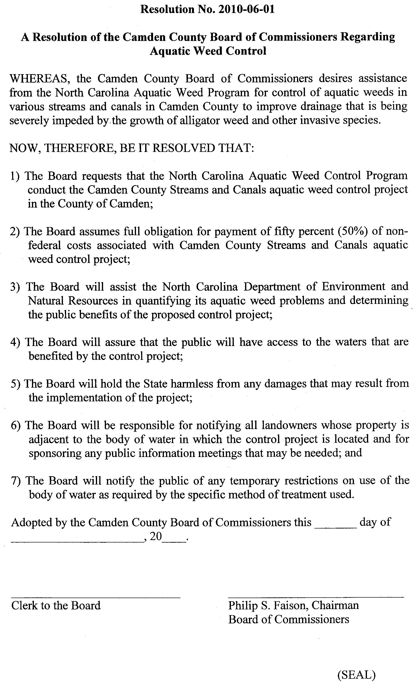

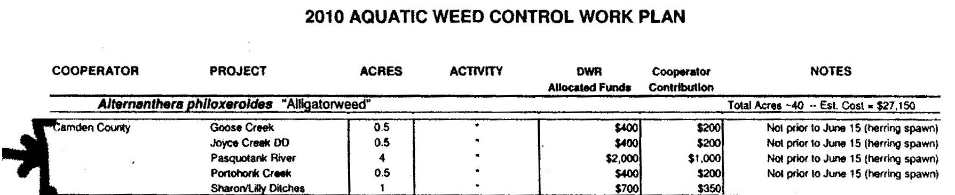

Amendment to the Camden County Board of Commissioners Code of Ethics

Randell Woodruff described this amendment:

- This amendment is a result of a new requirement adopted last year by the General Assembly, requiring all Commissioners to undergo ethics training as well as all boards to adopt a new Code of Ethics.
  - Camden County has a Code of Ethics policy, it was adopted in 1991 or 1992.
  - Board packet includes copy of current Code of Ethics policy as well as the recommended model template policy from the Institute of Government
  - County Attorney John Morrison could not be here at this meeting, so if the Board so chooses, this item may be tabled until the next meeting wherein he will be available

Chairman Commissioner Phil Faison asked if all the Commissioners had read the material. All stated they had. Next he asked if all Commissioners had completed the Ethics Training Webinar. Mr. Woodruff stated that Commissioner Garry Meiggs had not yet completed the training. Chairman Faison further asked if the training was only for elected officials (commissioners) or if it included the County Manager, Attorney, and Clerk to the Board. Mr. Woodruff responded it was only for the elected commissioners.

Commissioner Michael McLain asked if this was a model code. Courtney Hull, Associate County Attorney, responded that this is the template from the Institute of Government on Ethics and in John Morrison’s correspondence on the matter, he indicated that this was a model code of ethics from the Institute of Government for NC Elected Officials. Ms. Hull further stated that this is the model that the Institute is recommending for counties.

Vice Chairman Commissioner Sandra Duckwall observed that since it is a requirement by the General Assembly, and since this is the model / template that is recommended by the Institute of Government, she sees no reason not to adopt this now. Mr. Woodruff stated that if there were no questions for the county attorney, then the Board could move forward with it if that is their desire.

Vice Chairman Commissioner Sandra Duckwall made a motion to Adopt the Amendment to the Camden County Board of Commissioners Code of Ethics, model / template as recommended by the NC Institute of Government. The motion passed 5-0, with Chairman Commissioner Phil Faison, Vice-Chairman Commissioner Sandra J. Duckwall, Commissioners Melvin Jeralds, Garry Meiggs, and Michael McLain voting aye; no Commissioner voting no; no Commissioner absent; and no Commissioner not voting.

Cancellation of July 6, 2010 Regular Meeting

Randell Woodruff stated that this was just a reminder to the Board that the normal meeting date for the first Monday in July fell on July 5, which is a state holiday, and so the meeting was scheduled for July 6, 2010. The Board has the option to hold the meeting or cancel it.

Chairman Commissioner Phil Faison and other Board members by consensus stated the meeting would proceed as scheduled.

THE MEETING FOR JULY 6, 2010 WAS NOT CANCELLED.

FY2010-11 Fee Schedule

Chairman Commissioner Phil Faison asked if there were any questions from the Board regarding the FY2010-11 Fee Schedule. Hearing none, he called for a motion.

Commissioner Michael McLain made a motion to approve the FY2010-11 Fee Schedule. The motion passed 5-0, with Chairman Commissioner Phil Faison, Vice-Chairman Commissioner Sandra J. Duckwall, Commissioners Melvin Jeralds, Garry Meiggs, and Michael McLain voting aye; no Commissioner voting no; no Commissioner absent; and no Commissioner not voting.

Board Appointments

Complex Security Committee

Randell Woodruff, County Manager described this agenda item:

- This is on the agenda as a result of a discussion held during the budget process in which there was a consensus of the Board that a Security Committee be appointed to look into the study of security related issues in our county office complex.
- Would be appropriate to include key department heads and a commissioner on that committee
- Makeup of committee to be between 4-5 people initially

Commissioner Michael McLain commented that he had a list of people who he thought would be good for this committee: Clerk of Court, Register of Deeds, County Manager, Someone from Sheriffs Department, etc. Randell Woodruff suggested that Public Works Manager needed to be on that as well, a commissioner, and perhaps someone from the Department of Social Services.

Chairman Commissioner Phil Faison called for a motion to approve a 7 person Board for Security. Vice Chairman Commissioner Sandra Duckwall made the motion to Approve a 7 person Security Committee to be made up of the Clerk of Court, Register of Deeds, County Manager, Someone from Sheriffs Department, Public Works Manager, Someone from Department of Social Services, and 1 commissioner. The motion passed 5-0, with Chairman Commissioner Phil Faison, Vice-Chairman Commissioner Sandra J. Duckwall, Commissioners Melvin Jeralds, Garry Meiggs, and Michael McLain voting aye; no Commissioner voting no; no Commissioner absent; and no Commissioner not voting.

Commissioner’s Report

None

County Manager’s Report

None

At 8:02 p.m., Vice Chairman Commissioner Sandra Duckwall made a motion to recess the June 7, 2010 Camden County Board of Commissioners meeting for the purposes of convening the South Camden Water and Sewer District Board of Directors meeting. The motion passed 5-0, with Chairman Commissioner Phil Faison, Vice-Chairman Commissioner Sandra J. Duckwall, Commissioners Melvin Jeralds, Garry Meiggs, and Michael McLain voting aye; no Commissioner voting no; no Commissioner absent; and no Commissioner not voting.

At 8:20 p.m., Chairman Commissioner Phil Faison reconvened the Camden County Board of Commissioners meeting.

Closed Session

Closed Session - Pursuant to G.S. 143-318.11(a)(3) - Consultation with Attorney and Pursuant to G.S. 143-318.11(a)(6) - Personnel

At 8:21 p.m. Commissioner Michael McLain made a motion to enter closed session Pursuant to G.S. 143-318.11(a)(3) - Consultation with Attorney and Pursuant to G.S. 143-318.11(a)(6) - Personnel. The motion passed 5-0, with Chairman Commissioner Phil Faison, Vice-Chairman Commissioner Sandra J. Duckwall, Commissioners Melvin Jeralds, Garry Meiggs, and Michael McLain voting aye; no Commissioner voting no; no Commissioner absent; and no Commissioner not voting.

The Board entered closed session at 8:21 p.m.

After consulting with attorney pursuant to G.S. 143-318.11(a)(3) regarding personnel matters pursuant to G.S. 143-318(a)(6), Commissioner Michael McLain made a motion to exit closed session and re-enter regular session of the Camden County Board of Commissioners Meeting. The motion passed 5-0, with Chairman Commissioner Phil Faison, Vice-Chairman Commissioner Sandra J. Duckwall, Commissioners Melvin Jeralds, Garry Meiggs, and Michael McLain voting aye; no Commissioner voting no; no Commissioner absent; and no Commissioner not voting.

Chairman Commissioner Phil Faison stated that no action was taken regarding personnel in the aforementioned closed session.

Information from Board and Staff

None

Chairman Commissioner Phil Faison asked if there were any other matters to come before this Board, hearing none, he asked for a motion to adjourn the meeting. Commissioner Michael McLain made a motion to adjourn the Camden County Board of Commissioners meeting for June 7, 2010. The motion passed 5-0, with Chairman Commissioner Phil Faison, Vice-Chairman Commissioner Sandra J. Duckwall, Commissioners Melvin Jeralds, Garry Meiggs, and Michael McLain voting aye; no Commissioner voting no; no Commissioner absent; and no Commissioner not voting.

Chairman Phil Faison
Camden County Board of Commissioners

ATTEST:

Amy D. Barnett
Interim Clerk to the Board

