Camden County Board of Commissioners
Regular Meeting
November 15, 2010
6:00 P.M. - Closed Session
7:00 P.M. - Regular Meeting
Historic Courtroom, Courthouse Complex
Camden, North Carolina

MINUTES

The regular meeting of the Camden County Board of Commissioners was held on Monday November 15, 2010 in the Historic Courtroom, Camden, North Carolina. The following Commissioners were present:

Chairman Phil Faison,
Commissioners Garry Meiggs, and Michael McLain.

Also attending were County Manager Randell Woodruff, Interim Clerk to the Board Amy D. Barnett, Newly Hired Clerk To The Board Ashley R. Honaker, and County Attorney John Morrison. Present for purposes of making a presentation(s) or providing supporting information for agenda items were the following persons: Dan Porter, Director of Planning; Dave Parks, Permit Officer and Flood Administrator, Roy Wilson of East Carolina Behavioral Health, Joy Futrell, ECBH Finance Officer, Lisa Wainright, ECBH Chief Operating Officer, Mary Gaskins, Tax Administrator. The following persons spoke during public hearing for Camden Plantation: David Rudiger, Boyd Homes, Ken Merner, Boyd Homes, Jean Bell of South Mills, Marcella Whitson of South Mills, Durward Medlon of South Mills, Jeenie Swanger, William Stafford of South Mills, Carolyn Riggs of Shiloh, Thad Forehand of South Mills.

Chairman Phil Faison called to order the November 15, 2010 meeting of the Camden County Board of Commissioners at 6:00 PM.

Closed Session, 6:00 P.M. Pursuant to G.S. 143-318.11(a)(3) - Consultation with Attorney & Pursuant to G.S. 143-318.11(a)(6) - Personnel

Commissioner Michael McLain made a motion to go into closed session pursuant to G.S 143-318.11(a)(3) for consultation with attorney and pursuant to G.S 143-318.11(a)(6) for personnel matters. The motion passed 3-0 with Chairman Phil Faison, Commissioners Garry Meiggs, and Michael McLain voting aye; no Commissioner voting no; two Commissioners absent; and no Commissioner not voting.

The Commissioners entered closed session at 6:00 P.M.

Commissioner Michael McLain made a motion to come out of closed session at 6:50 P.M. The motion passed 3-0 with Chairman Phil Faison, Commissioners Garry Meiggs, and Michael McLain voting aye; no Commissioner voting no; two Commissioner absent; and no Commissioner not voting.

Chairman Phil Faison recessed the Board at 6:50.

Regular Session, 7:00 P.M.

Chairman Phil Faison re-convened the November 15, 2010 meeting of the Camden County Board of Commissioners at 7:00 P.M. for the Regular Session.

Invocation and Pledge of Allegiance

Chairman Phil Faison gave the invocation and led those present in the Pledge of Allegiance.

Public Comments - None

Appointment of Ashley Honaker as Clerk To The Board

Chairman Faison asked for the appointment of Ashley Honaker as the Clerk To The Board. Not hearing any opposition, Commissioner Meiggs made a motion to appoint Ashley Honaker. The motion passed 3-0 with Chairman Phil Faison, Commissioners Gary Meiggs and Michael McLain voting aye; no Commissioners voting no; two Commissioners absent; and no Commissioner voting no.

Consideration of Agenda

Chairman Phil Faison asked if there were any changes to the agenda. Not hearing any changes, he called for a motion to approve the agenda.

Commissioner Michael McLain made a motion to approve the agenda as presented. The motion passed 3-0 with Chairman Phil Faison, Commissioners Garry Meiggs, and Michael McLain voting aye; no Commissioner voting no; two Commissioner absent; and no Commissioner not voting.

Public Hearing

Public Hearing
Item 4. A. Camden Plantation Master Plan & Conditional Use Permit (Pg 1-98)

Chairman Phil Faison called for a motion to enter into the Public Hearing.

Commissioner Garry Meiggs made the motion to enter into public hearing. The motion passed 3-0 with Chairman Phil Faison, Commissioners Garry Meiggs, and Michael McLain voting aye. No Commissioners voting no, two Commissioners absent, and Commissioners not voting.

County Attorney John Morrison spoke to the audience and explained the Quasi Judicial process:
- Everyone who wishes to speak to the Board must be sworn in.
- The only things that the Board can consider is if the developer has followed the rules of the Unified Development Ordinance.
- Popularity of the issue is not a consideration
- The following 4 key questions are what should be considered:
  - Whether or not this development would endanger the public health and safety.
  - Whether or not it would harm the property value of adjacent property.
  - Whether or not the proposed development area is in harmony with surrounding area.
  - Whether or not the County will have the ability to provide public facilities.
- Public is limited to 3 minutes for presentation without redundancy.
- Anyone sworn in has the choice to volunteer their 3 minutes to another.
- Anything wished to be shown to the Board must be given and approved by County Attorney John Morrison first.
- County Attorney John Morrison kept time and informed Chairmen Phil Faison when each citizens time was up.

Planning Director Dan Porter gave a brief summary on the Camden Plantation Master Plan. The Planning Board met on October 20, 2010 and passed the Master Plan 4-1. He handed out a packet to the Board, which included materials and notes form the technical review meeting , draft minutes of the Planning Board, project impact of water, sewer, and school capacity, and the affects of property taxes, planning department has a complete set of plans online and in their office, a revised Phasing & Land Use Tabulation table, and a letter received from adjacent property owners.

County Attorney John Morrison reviewed the submitted letter from the adjacent landowner Wilbur and Marcella Whitson and ruled it as heresay.

Dan Porter showed GIS maps of Camden Plantation including land use, zoning, flood zone, and suitability maps. Dan also presented the Camden Plantation summary document and went over figures, land configurations, land and water configurations/systems, road configurations, stormwater figures including 3 water sheds with the largest being Joyce Creek. Dan stated that the stormwater cannot runoff faster post-development than it does pre-development with the inclusion of the 10-year storm. Dan presented the Golf Course plans, showing the inclusion of built-in wetlands for stormwater control, the reuse from the sewer plant to irrigate the golf course, as well as put in additional wetlands to counter those destroyed by development. The Primary access to Camden Plantation will be from Highway 17, with two secondary access; to the North and East on McPherson Rd. There will be individual neighborhood pods consisting of various size and styled and number of homes, with 4 continuing phases of development. The Master Plan includes circulation and walking patterns as well as various public parks near the neighborhoods. Provided GIS maps showing existing wetlands, as well as where proposed wetlands will be, and where man-made ponds will be located. Showed where the town center will be developed in a radial manner, primary recreation and amenity locations, varying types of poles, street lights, street signs, etc. Showed the golf course layout and the virtual buffers between the course and neighboring properties equaling to 50 feet.

The Planning Board recommended approval of the Camden Plantation Master Plan with 47 conditions.

Dave Parks presented the 47 conditions to the Board:
- The applicant must strictly abide by all requirements of the Unified Development Ordinance of Camden County, North Carolina, and must also strictly comply with all other local, state, and federal ordinances, laws, rules and regulations as one or more ordinances, laws, rules and regulations may apply to this development.
- The applicant shall complete the development strictly in accordance with the approved Master Plan approved by the Board of Commissioners of Camden County, North Carolina, and contained in the file titled (UDO 2010-08-17)
- There shall be two copies of the approved Master Plan signed by both the applicant and the Chairman Camden County Board of Commissioners.
- Prior to any land disturbing activity the applicant and Camden County shall enter into a development agreement that shall address at a minimum the requirements of N.C.G.S. 153A-349.1 thru 153A-349.13.
- Amend Master Plan to reflect the following:

a. On Page 1, add signature blocks as follows:

__________________________________________ ____________
Chairman, Camden County Board of Commissioners Date

__________________________________________ ____________
President Camden Plantation Properties Date

b. Page 8 – 1) Amend Development phasing schedule to reflect maximum 5 year increments (N.C.G.S. 153A-349.6); 2)
c. Page 9 – 1) delete words “a possible” commercial development and replace with “the” commercial development…..”
d. Page 16 – 1) Change the word “may” to “shall”
- Developer shall utilize and maintain as much existing tree cover as possible.
- There shall be no timbering/land clearing with the exception of clearing necessary to maintain property ditches and swales, prior to Preliminary Plat approval.
- Preliminary Plat Approval as referred to in this Conditional Use Permit refers to those items in UDO Section 151.298 that are referenced as “information sufficient to satisfy preliminary plat” whereby they must be consistent with the approved Concept Plan and Master Plan, and constitutes an administrative approval not requiring further approval of the Planning Board or Board of Commissioners. Minor amendments and refinements to the Master Plan may also be approved administratively, or at the discretion of the Administrator or the request of the Developer, may be referred to the approving body.
- The Camden Plantation project shall include’
a. 18 hole golf course (9 holes shall be developed prior to approval of Phase II of the project)
b. Community Center
c. Swimming Pool
d. Tennis Courts
e. Playground
f. Picnics Shelters
- All development within the project shall be linked with sidewalks and bike paths along primary and secondary roads, as well segregated pathways where appropriate.
- Primary access to the development shall be an entrance from US 17 and shall be designed in accordance to NC DOT requirements and shall be a boulevard with landscaped center median and monument type entrance sign. NC DOT approval shall be required prior to preliminary plat approval for Phase I.
- One secondary access shall be provided to McPherson Rd. on the north of the project and shall be designed in accordance to NC DOT requirements and shall be a boulevard with landscaped center median and monument type entrance sign. NC DOT approval shall be required prior to preliminary plat approval for Phase II.
- Another secondary access shall be provided to McPherson Rd. on the east of the project and shall be designed in accordance to NC DOT requirements and shall be a boulevard with landscaped monument type entrance sign. NC DOT approval shall be required prior to preliminary plat approval for Phase IV.
- A traffic impact analysis shall be required prior to approval of preliminary plat as required by NCDOT.
- All collector roads serving as access to individual neighborhoods shall be built to NC DOT design and construction standards.
- Interior neighborhood roads may be public or private streets and shall be built to NC DOT construction standards, and if not dedicated to the public may be built to the design standards as set forth in the Camden Plantation Private Access Road Construction and Maintenance Standards Manual dated August 2010 which is included by reference in this permit.
- All private roads shall be maintained by property owners association as outlined in the Camden Plantation Private Access Road Construction and Maintenance Standards Manual dated August 2010 which is included by reference in this permit, by the developer and property owners association. This condition shall be included in restrictive covenants for the development.

- All private roads shall be developed by the developer and maintained after transfer by the Property Owners Association in accordance with the Camden Plantation Private Access Road Construction and Maintenance Standards Manual dated August 2010 which is included by reference in this permit. This condition shall be included in restrictive covenants for the development.
- Each “Vest Pocket Park” or Primary Recreation Facility shall be developed to be accessible to each residential neighborhood, within reasonable walking distance to one another, and interconnected by the means of a trail system.
- Any infill of existing wetlands and/ creation of wetlands shall require approval from the Army Corp of Engineers prior to approval of preliminary plat of the phase in which it will occur. Mitigation of wetlands shall be at a ratio greater than 1 acre mitigated for each 1 acre filled.

- Any infill of existing wetlands and/or offsetting creation of wetlands shall require approval from the Army Corps of Engineers and any other required governmental agencies prior to approval of Preliminary Plat of the phase in which it will occur. Mitigation of wetlands shall meet all federal, state and local regulations
- There shall be no land disturbing activity prior to an approved DENR Storm Water Permit, Erosion & Sedimentation Control Plan, Camden County engineer approval on drainage plan, and Preliminary Plat approval. Each preliminary plat and commercial site plan shall require such review and approval. A set of “as-built” stormwater plans, signed and sealed by a North Carolina professional engineer, shall be submitted prior to final plat approval.
- All connection fees for water service and sewer service (if supplied by a public agency) shall:
  - Be paid prior to approval and filing of a final plat for the Phase being developed.
  - Set forth in a Development Agreement between the Developer, Camden County, and Service Provider.
    - All main roads and water distribution and sewer collection lines shall be laid out as generally shown on Sheet 7 of the Master Plan. The addition of roads and utilities to serve individual neighborhoods will be considered refinements and reviewed and approved upon submittal of preliminary plats.
    - All water distribution lines shall be turned over to and be subject to the terms and conditions of the service agreement with the South Mills Water Association.

- All water distribution lines and appurtenances shall be constructed by the developer and be subject to the terms and conditions of a service agreement between the developer and the water authority having jurisdiction
- If a private sewer system is developed, the treatment and collection system shall be approved by DENR prior to preliminary plat approval. Additionally a special service district shall be established for all properties served by the system prior to final plat approvals and shall comply with the regulations of the Camden County Sewer Ordinance.

- If a private sanitary sewer system is developed, it shall be constructed by the developer at no cost to the County and shall be approved by NCDENR prior to approval of Preliminary Plat of the phase in which it will occur. Additionally a Special Service District shall be established for all properties served by the system prior to Final Plat approvals. The system shall comply with the regulations of the Camden County Sewer Ordinance.
  - Sewer service shall be offered to existing owners of 61 adjacent properties previously developed in the initial phase of Camden Plantation.
  - Preliminary plat approval of each Phase shall require a letter from Albemarle Electric Coop agreeing to provide electrical service to the proposed development.

- Eliminate condition.
- All utility lines shall be placed underground.

- All new utility lines shall be placed underground except at utility connection points at the boundaries of the property where services may connect to existing overhead service lines.
- Development Phasing Schedule and Land Use Tabulation shall be as listed on the approved Master Plan and incorporated as part of this permit as Attachment’s “A” and “B” respectfully. The number of units per year or by type may be adjusted as a minor amendment approved administratively, however any increase to the maximum number of units or maximum density per phase shall require a major amendment.

- Initiation of subsequent phases may be allowed prior to completion of a previous phase, however in no case will the number of residential units, exceed the cumulative total units of preceding and current project year.
- Minimum Dimensions Table for Residential Development:
 | Manor | Carriage (conventional) | Carriage (with alley) | Villa/Patio (conventional) | Villa/Patio (with alley)
Min. Lot Size | 8800 | 7000 | 7000 | 5600 | 5600
Min Width  @building setback | 70 | 60 | 60 | 50 | 50
Front setback | 10 | 10 | 10 | 10 | 10
Side Yard | 0 | 0 | 0 | 0 | 0
Rear yard | 5 | 5 | 5 | 5 | 5
Between bldgs | 10 | 10 | 10 | 10 | 10
- Commercial site plans shall be required for each commercial, apartment, and community facilities building or sets of buildings. Commercial site plans shall require stormwater plans approved by DENR and Camden County’s stormwater engineering consultant.
- The commercial center site layout of buildings, parking, and circulation shall be located as shown on sheet 9 of the Master Plan and shall be designed to present a town center appearance. Out parcels as reflected on Master Plan to the town center may be developed, but in no case shall out parcels have direct access to US 17 or McPherson Rd. Any substantial change in number of commercial buildings, total square footage, or circulation patterns shall require major amendment; however minor variation in shape, size and footprint locations shall be considered minor amendments.
- The apartment complex site layout of buildings, parking, and circulation shall be generally arranged in the manner located as shown on sheet 16 of the Master Plan and shall be designed in an architectural style similar and complementary to the Camden Plantation neighborhood. Any increase in apartment units, or any substantial change in number of apartment buildings, units or circulation patterns shall require major amendment; however minor variation in shape, size and footprint locations shall be considered minor amendments. The apartment complex shall include sidewalks, common open space, a community clubhouse and related amenities.
- Parking for apartment buildings shall have minimum number of spaces as follows:
  - 1 bedroom units 1 space per unit
  - 2 bedroom unites 1.5 spaces per unit
  - 3 bedroom units 2 spaces per unit
- The Primary Recreation Facility site layout of buildings, parking, and circulation shall be located as shown on Sheet 17 of the Master Plan. Any substantial change in number of buildings or circulation patterns shall require major amendment; however minor variation in shape, size and footprint locations shall be considered minor amendments.
- Specifications for location and dimensions shall be provided prior to preliminary plat or commercial site plan approval for lighting, fencing, landscaping, sidewalks, and buffers.
- A minimum 50 foot landscaped buffer shall be provided between any lot within the development and either of the adjacent golf course, adjacent residential lots not within the development, or US 17.
- Walking/biking trails within the development shall be 8 feet wide with a minimum 6 foot buffer on each side
- Entrance signs at primary and secondary access points to Camden Plantation shall be reviewed and approved by the Board of Commissioners prior to preliminary plat for the phase in which they are being constructed.
Entry signs to project neighborhoods shall not exceed the dimension as shown/described in the “Signage Standards for Camden Plantation Neighborhoods” included as attachment C to this permit. Specific design and location shall be submitted prior to preliminary plat approval.
(Recommending consolidate conditions 38 & 39 to read as follows)

- Entry signs to Camden Plantation and those signs to and within project neighborhoods, commercial areas and recreational areas shall be developed in accordance with sign criteria determined within the Development Agreement. Specific design and location of signs shall be submitted prior to approval of the Preliminary Plat of the phase it will occur.
- Ground water shall not be used for commercial purposes including, but not limited to, irrigation of the golf course.

- A hydrological groundwater study shall be prepared and submitted to Camden County prior to any substantial withdrawal of groundwater (i.e. greater than would customarily be used in connection with a single residential structure) for any commercial purposes, including irrigation of the proposed golf course.
- Developer shall pay at preliminary and final plat application the per lot fee in accordance with the Camden County Fee Schedule for Major Subdivisions which is as follows:
  - Preliminary Plat - $200.00 per lot
  - Final Plat - $50.00 per lot
- Changes to the Master Plan that shall be considered Major Amendments include:
  - Increase in total residential units in any phase
  - Increase in residential density in any phase

* Additional changes to be determined by the Board of Commissioners.
- Developer shall provide County an updated page (indicating revision #) of the Master Plan that is considered a major amendment within 15 days of approval.
- A copy of the signed approved Master Plan shall be maintained in the Camden County Registry of Deeds.
- The approved signed Conditional Use Permit shall be recorded in the Camden County Registry of Deeds within 45 days of approval.
- If any of the conditions affixed hereto or any part thereof shall be held invalid or void, then this Conditional Use Permit shall be voided and have no effect.

- If any of the conditions affixed hereto or any part thereof shall be held invalid or void, then this Conditional Use Permit shall remain in full force and effect as to all then recorded parcels, but if any substantial condition is invalidated, the County may terminate this Conditional Use Permit as to any future improvements and parcels (other than common amenity improvements) unless an until a substitute condition or conditions acceptable to the City and the developer are in place.

- In connection with or prior to the development of each portion of the property which adjoins the property not owned by Developer an located generally at the intersection of US 17 and McPherson Road, Developer shall install a 6’ high fence generally along the joint property line of the property of Developer which is being developed and such adjoining property

Dan Porter submitted a revised Land Use Tabulation table.

Public Comment:

County Attorney John Morrison asked for all of those in favor of Camden Plantation to speak first.

David Riduger of Boyd Homes came forward. He was sworn in. David described the multi-family (apartments) pod of Camden Plantation as being located on the corner of McPherson and US 17, and wanting to relocate it into an internal pod. David mentioned that he had met with adjacent property owners about the multi-family pod location, and that steps were being made to relocate into a more central pod inside of Camden Plantation.

Ken Merner of Boyd Homes. He had nothing to add, but volunteered himself for any questions.

County Attorney John Morrison called for all those opposing the Camden Plantation to come forward and speak.

Jean Bell at 107 McPherson Rd. in South Mills. She had been sworn in. Mrs. Bell stated that she did not 3 to 4 units of apartments in her backyard. She stated that even though they were being proposed as moved, they were still there near her property. Mrs. Bell then asked those in the audience who also did not want apartments in their backyard to please quietly stand. She also stated that while she did not have a problem with the other architectural styles of home being proposed, there were still potential infrastructure problems.

Marcella Whitson at 222 Culpepper rd. of South Mills. She had been sworn in.

County Attorney John Morrison stated that the witness Marcella Whitson had validated her letter to the Board and that it could be considered as evidence.

Mrs. Whitson had concerns about possible downstream flooding, and requested several amendments to the conditions presented by the Planning Board. Mrs. Whitson spoke about previous 1999 proposed development Tanglewood. She presented a letter from Dwain Hinson dated June 14, 1999, stating that the lack of downstream maintenance in the proposed area can have severe consequences to the surrounding land and property owners. The Joyce Creek water maintenance project ends at Culpepper rd leaving approximately 1500 feet of unmanaged watershed. Mr. Hinton met with Jay Overton of Albemarle and Associates and indicated that a maintenance easement would be sought to improve and maintain the 1500 foot area south of the subdivision. She introduced a letter from July 19, 1999 from personal attorney to the respective Planning Board, stating that Mr. Hinson had indicated that Tanglewood poses severe consequences to downstream property owners with the lack of downstream ditch management. Mrs. Whitson at that point ran out of time and asked for later deferment of minutes.

Durward Medlin at 105 Lake Dr. of South Mills. Mr. Medlin asked if the 47 conditions presented by the Planning Board were something that had to be voted on by the Board or was it an assumed adoption by the Planning Board. Board answered “Correct”. Mr. Medlin asked if 3 presiding members could vote or if there had to be 5 members present. Board answered “yes”. Mr. Medlin then deferred his existing 2 minutes to Mr. William Stafford.

Jeenie Swanger at 138 Bunkerhill Rd of South Mills. Mrs. Swanger spoke briefly about the current flooding problems associated with Joyce Creek. She referenced that during a recent storm, she was stuck in her home for days due to flooding of Joyce Creek. Mrs. Swanger suggested that Joyce Creek needed to be dredged before any more development went into the area.

Nancy Carey Gave her 3 minutes to Mr. Stafford. 4 other people gave their 3 minutes to Mr. Stafford. Mr. Stafford then had 21 minutes.

William Stafford at 102 Lake Dr. of South Mills. Mr. Stafford stated that he was not against all development, but that he wanted to make sure that it was done correctly. He did not want this project to go through and for it to end up being empty lots along US 17. Mr. Stafford stated that a hydrological study had not been done at this point, and that he was concerned for a pond locate don his property. Mr. Stafford referred to a discussion in 2006 with Superintendent Ron Melchiorre and the respective Board of Commissioners discussing schools problems in the area including:
- The difference between adequate and making due in school facilities (adequate facilities do not include trailors)
- The need for a new High School at the cost of $40 Million
- The need for a new elementary school at the cost of $30 Million
- The fact that state money is drying up and stimulus money may never come again
- Camden County cant afford to build more schools
- Camden removed Adequate Public Facilities Ordinance
Mr. Stafford pointed out that now that Camden is faced with a PUD, there is no APFO. An APFO for Camden Plantation would have brought in $17,772,000. Mr. Stafford asked the Board to please not forget the normal county growth outside of the proposed Camden Plantation. The county of Camden would receive $141,000 per year in tax, while Camden Plantation would receive in excess of $300,00 per month. Camden Plantation would generate 2.9 children per home, with over 1,700 home projected. Mr. Stafford moved on to say that a study was done on McPherson Rd., on what was originally phase 1 of Camden Plantation, there were 61 lots, 25 homes, and 2 unsold houses. There were 25 children in all age groups combined. By Year 2016, the county projects an annual tax revenue of $644,610, which is the end of Phase 1, with the annual cost of the school system equaling to over $1 Million. “It is important to recognize that some unstable communities, the revenue required to support new development may not even be available, even if the community desperately needs that development”. Mr. Stafford continued on speaking about South Mills Water cannot handle Phase 1 without a long-term commitment from Camden water. Mr. Stafford also brought up traffic issues, Camden school transportation, health and senior. Mr. Stafford warned that the local farmers needed to be heard, because they work the land and know how the water runs in that area, and that this area had been referred to as the bathtub of Camden County. Mr. Stafford also brought up the issue of public services such as police and fire departments. There will be 3,000-4,00 people and property to protect in one small area. Mr. Stafford warned that there was only one chance to get the plan right, and urged the Board to deny the plan and return it to the Planning Board. He asked that a public meeting be held so that Boyd Homes can fix the problems and move forward without problems form the public.

Mr. Stafford presented a survey to the Board with 515 names of people in opposition of the Camden Plantation.

County Attorney John Morrison declared that those 515 people were not present or sworn in therefore it could not be considered.

Carolyn Riggs at 157 Milltown Rd. of Shiloh. Mrs. Riggs briefly addressed the issue of residents of Camden County outside of South Mills, directing attention to quality of Life and taxes. She was concerned that school capacity would be breached. She also asked whether current taxes and tax rates can support the infrastructure. Mrs. Riggs suggested that construction of the commercial district come first to provide proof of growth stability in South Mills and Camden County.

Thad Forehand at 106 Park Dr. of Shiloh. Mr. Forehand was there on behalf of Melvin Hawkins, Superintendent, and pointed out that currently Grandy Primary School is currently 75 students away from capacity, and Camden County High School is currently 33 students over capacity. Mr. Forehand stated that there is already a dire need for new schools, and that need will only increase with the addition of Camden Plantation.

Marcella Whitson came forward to speak to the Board. Mrs. Whitson pointed out the need for a sewage treatment facility. She spoke about the need for no ground water, and asked the Board to confirm the Planning Boards condition of No Ground Water. Mrs. Whitson asked the Board if a caps had been issued for the schools.

County Attorney John Morrison replied that the county has an APFO in place that allows it to deny development if adequate facilities are not currently in place, however other courts in other counties have stricken that or greatly diminished its authority.

Commissioner Garry Meiggs made the motion to close out of public meeting at 8:45 PM. The motions passed 3-0 with Chairman Phil Faison, Commissioners Garry Meiggs, and Michael McLain voting aye; no Commissioners voting no; two Commissioners absent; no Commissioners not voting.

Consent Agenda

Item 5. (A.-g.)

Commissioner Michael McLain made a motion to approve the Consent Agenda. The motion passed 3-0 with Chairman Phil Faison, Commissioners Garry Meiggs, and Michael McLain voting aye; no Commissioner voting no; two Commissioner absent; and no Commissioner not voting.

Consent Agenda

A. Draft Minutes - October 4, 2010 and November 1, 2010

B. Budget Amendments - 2010-11-BA016C

2010-11-BA016C
CAMDEN COUNTY BUDGET AMENDMENT

BE IT ORDAINED by the Governing Board of the County of Camden, North Carolina that the following amendment be made to the annual budget ordinance for the fiscal year ending June 30, 2011

Section 1. To amend the Social Services Fund as follows:

AMOUNT
ACCT NUMBER DESCRIPTION OF ACCT INCREASE DECREASE

Expenses:

526100-502000 Salaries $4,615.00
562100-505000 FICA $ 353.00
562100-507000 Retirement $ 302.00
526100-507100 401K $ 231.00

Revenues:

52390610-439900 Fund balance appropriated $2,751.00
52330610-434802 Administration $2,750.00

Section 2. Copies of this budget amendment shall be furnished to the Clerk to the Governing Board, and to the Budget Officer and the Finance Officer for their direction. Adopted this 1st day of November, 2010.

Clerk to Board of Commissioners Chairman, Board of Commissioners

2010-11-BA018
CAMDEN COUNTY BUDGET AMENDMENT

BE IT ORDAINED by the Governing Board of the County of Camden, North Carolina that the following amendment be made to the annual budget ordinance for the fiscal year ending June 30, 2011

Section 1. To amend the General Fund as follows:

AMOUNT
ACCT NUMBER DESCRIPTION OF ACCT INCREASE DECREASE

Expenses:

105900-592000 I/C Transportation $13,310.00

Revenues:

10330590-434803 DOT Grant $13,310.00

Notice of additional funding received.

This will result in a decrease of 0.00 in the Contingency of the General fund.

Balance in the Contingency is $71,466.00

Section 2. Copies of this budget amendment shall be furnished to the Clerk to the Governing Board, and to the Budget Officer and the Finance Officer for their direction. Adopted this 15th day of November, 2010.

Clerk to Board of Commissioners Chairman, Board of Commissioners

2010-11-BA019
CAMDEN COUNTY BUDGET AMENDMENT

BE IT ORDAINED by the Governing Board of the County of Camden, North Carolina that the following amendment be made to the annual budget ordinance for the fiscal year ending June 30, 2011

Section 1. To amend the APSC Fees Fund as follows:

AMOUNT
ACCT NUMBER DESCRIPTION OF ACCT INCREASE DECREASE

Expenses:

174900-554310 Refund Expense $19,439.00
174900-597100 Transfer to General Fund $ 1,389.00

Revenues:

17340490-435400 Land Use Fees $19,439.00
17399490-439900 Fund Balance Appropriated $ 1,389.00

Additional fees were received and must be refunded. Fund closed with interest transferred to General Fund.

Section 2. Copies of this budget amendment shall be furnished to the Clerk to the Governing Board, and to the Budget Officer and the Finance Officer for their direction. Adopted this 15th day of November, 2010.

Clerk to Board of Commissioners Chairman, Board of Commissioners

2010-11-BA020
CAMDEN COUNTY BUDGET AMENDMENT

BE IT ORDAINED by the Governing Board of the County of Camden, North Carolina that the following amendment be made to the annual budget ordinance for the fiscal year ending June 30, 2011

Section 1. To amend the Social Services Fund as follows:

AMOUNT
ACCT NUMBER DESCRIPTION OF ACCT INCREASE DECREASE

Expenses:

528000-535000 FEMA Grant $250.00
528000-538100 TANF Domestic Violence $705.86

Revenues:

52360610-402000 FEMA Grant $250.00
52330610-434829 TANF Domestic Violence $505.00
52330610-434829 Family Violence Protection Act $1,210.86

Additional grant & FY10-11 state allocation.

Additional fees were received and must be refunded. Fund closed with interest transferred to General Fund.

Section 2. Copies of this budget amendment shall be furnished to the Clerk to the Governing Board, and to the Budget Officer and the Finance Officer for their direction. Adopted this 15th day of November, 2010.

Clerk to Board of Commissioners Chairman, Board of Commissioners

C. Camden County School Budget Amendments:
a. Capital Outlay Fund

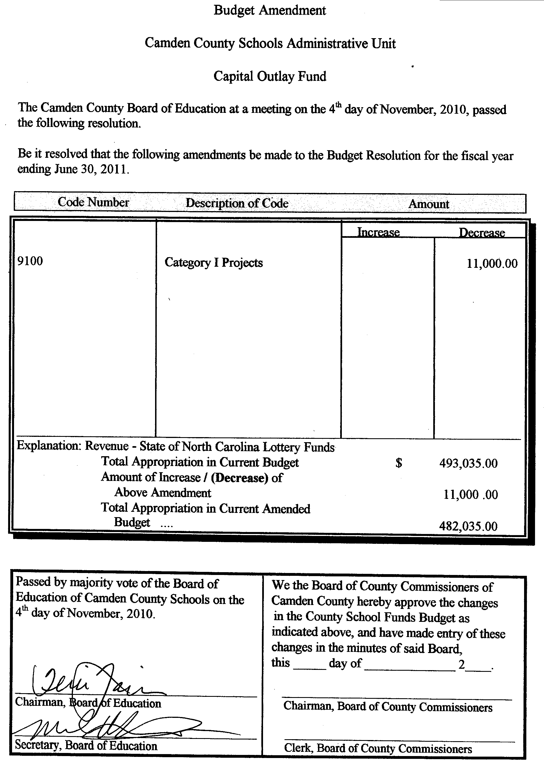
b. Local Current Expense Fund

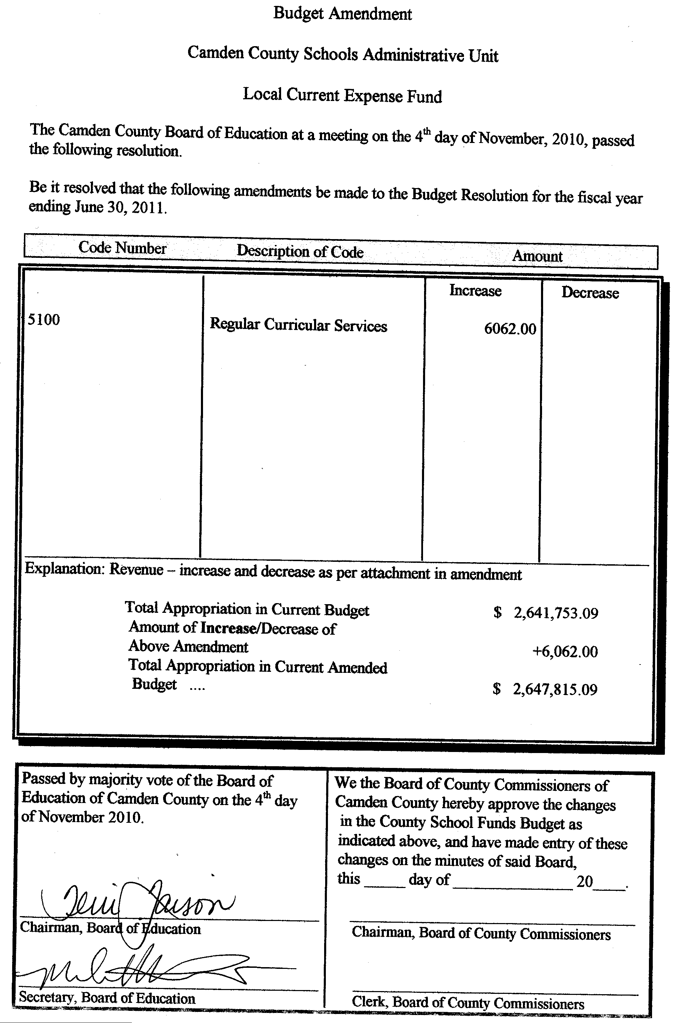

D. Tax Collection Report, October 2010 in the amount of $339,075.13

E. Tax Refunds, Pickups, & Releases

Name Amount Type Reason No.
Celestino Perez $120.18 Refund Military Exempt 154516
Sheldon M. Charles $156.54 Release Military Exempt 12941
Melissa L.D Anderson $122.20 Release Military Exempt 12929
Kelly M.B. Baronas $207.64 Release Military Exempt 12927
Thelma H. Benton $1,755.32 Release Transfer Correction 12944
Willie A. Dozier $422.37 Pickup New Lot- split from 02-8934-03-42-9138, 12898
Thomas & Brenda Terepaugh , $807.92 Pickup New Lot- Split from 02-8934-03-42-9138, 12897
Christopher W. Knight $100.00 Pickup Code Enforcement Fee 12932
Lance W. Harger $100.00 Pickup Code Enforcement Fee 12931
Jason W. Jennings $100.00 Pickup Code Enforcement Fee 12930
Dwayne & Glenda Harris $300.00 Pickup Code Enforcement Fee 12928
Benjamin W. Benton Jr. $1,755.32 Pickup Transfer Correction 12945
JCB Construction Inc $445.30 Pickup Value Adjustment 12943
JCB Construction Inc $651.96 Pickup Never Billed 12943
Willie Dozier & Joyce +$33.48 Adjustment Lot Size Increase 12896
Willie Dozier -$963.47 Adjustment Portion of Property Sold 12895
K&G Farm Inc +$352.85 Adjustment Value Adjustment 12894

New Business

New Business
Item 6. A-B. Presentation: Roy Wilson of East Carolina Behavioral Health- Semi Annual Report. Monthly Tax Report, October 2010, Mary Gaskins, Tax Administrator.
Roy Wilson gave a presentation on ECBH update, and a budget presentation. The budget presentation is required by law.
- Joy Futrell, Chief Finance Officer,
- Chief Operations officer Lisa Blainright.

Commissioner McLain asked ECBH if they were in the medical park facility

Roy Wilson responded by saying Yes, and that they were a manager of care, not a provider of care.

Commissioner McLain if ECBH referred services to those in need.

Roy Wilson responded by saying Yes.

Lisa Blainright provided a phone number, 1-877-685-2415, for those in need or with questions to call at anytime. Lisa also spoke of billboards going up in the area advertising that telephone number, and the possibility of making appointments.

Roy Wilson also added that the telephone number would access care providers in the callers area.

Lisa Blainright reported on the September 30 Quarterly report, which included a table located in the board packet.
- The 1st 3 columns are the audit report, while the 1st 2 consist of ECBH information.
Lisa went over the document listed on page 167 of the board packet,
- service management funds $7.5 Million
- service delivery funds $37 Million
- total budget amount $58 Million
- 86% of budget made up of dollars to pay for services to for consumers
- Current estimated unrestricted fund balance $11.1 Million

Chairman Faison thanked them, and continued in asking for the tax report from Mary Gaskins.

Mary Gaskins, Tax Administrator, went over the figures listed on that tax report for October 2010 provided to the commissioners in the board packet.
- The total Real Estate taxed for 2001-2010 at just over $5 Millions.
- The total Personal Property tax for 2001-2010 at $322,286
- The 10 year average percentage collection at 91.83%
- Total October collection for 2010 versus 2009
- Total collection rate for 2008-2010
- 30 Largest and oldest unpaid accounts

Mary added a correction to the 30 largest and oldest, stating that number 11 on the list should not be on the report (ATT. A). She also stated that majority of attachment A are payment plans.

Commissioner’s Report

Commissioner Garry Meiggs presented Chairman Phil Faison with a farewell plaque from the entire board in representation of their good luck and well wishes on his departure from the Board.

County Manager’s Report

County Manager, Randell Woodruff had the following items to report:
- Homeowners litigation
  - Meeting with local coastal and NE counties
  - Ensuring that local homeowners are not paying too high of a homeowners insurance for the area.
- The Tree Lighting Ceremony will be held on December 1, 2010 at 7:00PM
- South Mills Fire Department Christmas Dinner Ruritan Club, Saturday, November 20th at 7:00PM
- Farmers City Banquet will be November 16, 2010 at the KE White Building at 7:00PM
- Receiving of the Clean Water Trust Fund equaling $864,100.
- The Veterans day Flag Raising ceremony was a success, with a large crowd turnout.

South Camden Water & Sewer District Board of Directors

Commissioner Meiggs made the motion to recess the Board of Commissioners meeting and go into the SCWD Board of Directors Meeting at 9:07PM,
The motion passed 3-0, with Chairman Phil Faison, Commissioners Garry Meiggs, and Michael McLain voting aye; no Commissioners voting no; two Commissioners absent; No commissioners not voting.

Commissioner McLain made the motion to approve the consideration of Agenda Amendments. The motion passed 3-0 with Chairman Phil Faison, Commissioners Garry Meiggs, and Michael McLain voting aye; no Commissioners voting no; two Commissioners absent; no Commissioners not voting.

Commissioner Meiggs made the motion the approve the draft minutes for September 7, 2010, October 4, 2010, and November 1, 2010. The motion passed 3-0, with Chairman Phil Faison, Commissioners Garry Meiggs, and Michael McLain voting aye; no Commissioners voting no; two Commissioners absent; no Commissioners not voting.

Commissioner McLain made the motion to adjourn the SCWSD Board of Directors meeting and re-convene the Camden Board of Commissioners meeting. The motion was approved 3-0 at 9:08 PM, with Chairman Phil Faison, Commissioners Garry Meiggs, and Michael McLain voting aye; no Commissioners voting no; two Commissioners absent; no Commissioners not voting.

Re-convene Commissioners meeting

Item 10. 1-8. Information, Reports & Minutes From Other Agencies

Meeting Adjourned

At 9:08 P.M., Chairman Phil Faison asked if there were any other matters to come before the Board of Commissioners, hearing none, he called for a motion to adjourn the meeting.

Commissioner Michael McLain made a motion to adjourn the November 15, 2010 Board of Commissioners meeting. The motion passed 3-0 with Chairman Phil Faison, Commissioners Garry Meiggs, and Michael McLain voting aye; no Commissioner voting no; two Commissioner absent; and no Commissioner not voting.

The meeting was adjourned at 9:08 P.M.

Chairman Phil Faison
Camden County Board of Commissioners
ATTEST:

Amy D. Barnett
Interim Clerk to the Board

