Camden County Board of Commissioners
Regular Meeting
November 1, 2010
6:00 P.M. - Closed Session
7:00 P.M. - Regular Meeting
Historic Courtroom, Courthouse Complex
Camden, North Carolina

MINUTES

The regular meeting of the Camden County Board of Commissioners was held on Monday November 1, 2010 in the Historic Courtroom, Camden, North Carolina. The following Commissioners were present:

Chairman Phil Faison, Vice-Chairman Sandra J. Duckwall,
Commissioners Melvin Jeralds, Garry Meiggs, and Michael McLain.

Also attending were County Manager Randell Woodruff, Interim Clerk to the Board Amy D. Barnett, and County Attorney Courtney Hull. Present for purposes of making a presentation(s) or providing supporting information for agenda items were the following persons: Dan Porter, Director of Planning; Danielle Barco of Camden County Cooperative Extension Service, 4-H Horticulture Students Kayla Murphy, Sarah Bond, Andy Bond, Sully Goetz, and Adam Lannon (Adam spoke to the Board), Horticulture Team Coach Darlene Lannon was also present.

Chairman Phil Faison called to order the November 1, 2010 meeting of the Camden County Board of Commissioners at 6:00 PM.

Closed Session, 6:00 P.M. Pursuant to G.S. 143-318.11(a)(3) - Consultation with Attorney & Pursuant to G.S. 143-318.11(a)(6) - Personnel

Commissioner Michael McLain made a motion to go into closed session pursuant to G.S 143-318.11(a)(3) for consultation with attorney and pursuant to G.S 143-318.11(a)(6) for personnel matters. The motion passed 5-0 with Chairman Phil Faison, Vice-Chairman Sandra J. Duckwall, Commissioners Melvin Jeralds, Garry Meiggs, and Michael McLain voting aye; no Commissioner voting no; no Commissioner absent; and no Commissioner not voting.

The Commissioners entered closed session at 6:02 P.M.

Commissioner Michael McLain made a motion to come out of closed session at 6:25 P.M. The motion passed 5-0 with Chairman Phil Faison, Vice-Chairman Sandra J. Duckwall, Commissioners Melvin Jeralds, Garry Meiggs, and Michael McLain voting aye; no Commissioner voting no; no Commissioner absent; and no Commissioner not voting.

Chairman Phil Faison recessed the Board at 6:25.

Regular Session, 7:00 P.M.

Chairman Phil Faison re-convened the November 1, 2010 meeting of the Camden County Board of Commissioners at 7:00 P.M. for the Regular Session.

Invocation and Pledge of Allegiance

Commissioner Melvin Jeralds gave the invocation and led those present in the Pledge of Allegiance.

Public Comments - None

Consideration of Agenda

Chairman Phil Faison asked if there were any changes to the agenda. Not hearing any changes, he called for a motion to approve the agenda.

Vice Chairman Sandra Duckwall made a motion to approve the agenda as presented. The motion passed 5-0 with Chairman Phil Faison, Vice-Chairman Sandra J. Duckwall, Commissioners Melvin Jeralds, Garry Meiggs, and Michael McLain voting aye; no Commissioner voting no; no Commissioner absent; and no Commissioner not voting.

Old Business

Old Business
Item 3. A. Revised - Ordinance # 2010-09-01, An Ordinance Amending the Camden County Code of Ordinances, pertaining to Chapter 151: Unified Development, Table of Permissible Uses, Use Numbers 18.410, 18.420, and 18.430; Small, Medium, and Large Turbines utilized for wind energy.

Dan Porter made a brief introduction to this agenda item:
- Public hearing on this ordinance was held on 10/18/2010, wherein the Board deferred the vote on this ordinance until this meeting to have some of the ordinance language worked out.
- Four changes have been made to the Ordinance Language:
  - Ordinance Language: Line 399: (6) For medium and large scale wind energy facilities, application shall include documentation of compliance, and all studies and reports if required, from all applicable state and federal agencies, including, but not limited to NC Department of Environment and Natural Resources, Coastal Resources Commission, US Army Corps of Engineers, US Fish and Wildlife Service, and the NC Wildlife Resources Commission.
    - This language requires that the applicant provides us with information that they have been in contact with those agencies. If they don’t have any compliance issues, we need a letter to that effect. If they do have to provide some type of report, they provide that to us. This does not mean there are any particular local environmental assessment requirements, only documentation.
  - Ordinance Language: Line 413: - Documentation of an approved Interconnection Feasibility Study.
    - We had required with the application a copy of the power purchase agreement between the wind energy facility company and the utility company and what we have done is changed that to read ‘Documentation of an approved interconnection feasibility study’, which they have to do. We just need documentation that this has been done, and we can get this from the service provider.
  - Ordinance Language: Line 438: Zoning Permits shall be valid for a period of two years and may be renewable in the event that more data is needed by the applicant in order to determine the viability of a wind energy facility.
    - This deals with meteorological towers, we have said that we will make this a zoning permit and that the permit would be good for one year, then it would be renewable for one year increments. This change makes the zoning permit valid for two year periods and renewable in two year increments.
  - Ordinance Language: Line 527: Applicant shall provide prior to approval of building permits, an irrevocable letter of credit in favor of the County in an amount equal to the estimated removal cost of the Wind Energy Facility, less the salvage value of the equipment, which shall be issued by a federally chartered bank with a branch office in northeastern North Carolina at which the Letter of Credit may be drawn and paid in full in immediately available funds in the event the Wind Energy Facility Owner fails to decommission the Wind Energy Facility pursuant to the requirements of this Section.
    - We moved the requirement for providing an irrevocable letter of credit for the decommission of the wind facility from the application stage (special use permit) to the installation and design stage. Prior to the application for building permit, we would require that letter for the decommissioning rather than at the special use permit application stage.
  - ADDITIONAL CHANGE NOT LISTED IN ORDINANCE LANGUAGE, BUT MENTIONED BY DAN PORTER AT MEETING AND ADDED TO LANGUAGE AFTERWARDS: (a) Prior to issuance of any building permits for medium and large scale wind energy facilities, the applicant shall provide documentation of compliance, and all studies and reports if required, from all applicable state and federal agencies, including, but not limited to NC Department of Environment and Natural Resources, Coastal Resources Commission, US Army Corps of Engineers, US Fish and Wildlife Service, and the NC Wildlife Resources Commission.
    - In a further conversation, regarding the documentation of compliance with environmental issues (see first change), the state is requiring information from us for their permit. What we have done is moved the section from line 399 to line 495, right under installation and design, and we will have a new paragraph (a) (see above). We moved this from the application stage (special use permit) to the project issuance of the permit (building permit).

Commissioner Michael McLain observed that the last change was not in the document. Dan Porter responded that it was a last minute change, and that if the Board chose to approve the ordinance, it would be approved as submitted with the last change that he mentioned.

Ordinance No. 2010-09-01

A Ordinance
Amending the Camden County
Code of Ordinances

Camden County, North Carolina

BE IT ORDAINED BY THE CAMDEN COUNTY BOARD OF COMMISSIONERS as follows:

Article I: Purpose

The purpose of this Ordinance is to amend the Title 15 of the Camden County Code of Ordinances of Camden County, North Carolina, which was originally adopted by the County Commissioners on December 15, 1997, and subsequently amended and as otherwise incorporated into the Camden County Code.

Article II. Construction

For purposes of this Ordinance, underlined words (underline) shall be considered as additions to existing Ordinance language and strikethrough words (strikethrough) shall be considered deletions to existing language. New language of proposed ordinance shall be shown in italics (italics) and underlined.
Article III. Amend Chapter 151 as amended of the Camden County Code
which shall read as follows:

CHAPTER 151: UNIFIED DEVELOPMENT

§ 151.334 TABEL OF PERMISSIBLE USES.

USE# | DESCRIPTION | R-1 | R-2 | R-3 | CCD | NCD | HC | MC | GUD | I-1 | I-2
18.410 | Small turbines | S | S | S | Z | Z | Z | Z | Z | Z | Z
18.411 18.420 | Medium turbines | S | S | S | S | S | S | S | S | S | S
18.420  18.430 | Large turbines |  |  |  | S | S | S | S | S | S | S

§ 151.347 SPECIFIC STANDARDS.

(T) The following development standards and procedures shall apply to all Wind Turbines.

(1) The following definitions shall apply unless the context clearly indicates or requires a different meaning:

LARGE WIND ENERGY SYSTEM. A wind energy conversion system consisting of one or more wind turbine(s), a tower(s), and associated control or conversion electronics, which has a rated capacity of more than 20 kW.

SMALL WIND ENERGY SYSTEM. A wind energy conversion system consisting of a single wind turbine, a tower, and associated control or conversion electronics, which has a rated capacity of not more than 20 kW and whose primary intent is to generate power to on-site consumption.

WIND TURBINE HEIGHT. The height as measured from the lowest adjacent grade to the tip of the turbine when it reaches its highest elevation.

(2) Small wind turbine systems shall be a permitted in accordance with ' 151.334 (Table of Permissible Uses) subject to the following standards:

(a) Height shall be limited to 150 feet.

(b) Setback. The base of the wind turbine shall not be closer to surrounding property lines than the height of the wind turbine unless a NC Registered Professional Engineer certifies the fall zone of the wind turbine and appurtenances will be within the setback area proposed. In addition, no wind turbine shall be located closer to an inhabited structure on adjacent property than 1.5 times the height of the wind turbine. Relief from this section may be granted if the applicant can secure a permanent easement from the adjoining property owner(s) providing for a fall zone.

(c) Building permit requirements. A building permit shall be required and building permit applications for small wind energy systems shall be accompanied by standard drawings of the wind turbine structure, including the tower, base and footings. An engineering analysis of the tower certified by a licensed professional engineer which includes standards for ice/wind loading shall also be submitted. This analysis may be supplied by the manufacturer. Wet stamps shall not be required.

(d) Compliance with FAA regulations. Small wind energy systems must comply with applicable FAA regulations, including any necessary approvals for installations close to airports. Evidence of compliance or non-applicability shall be submitted with the application.

(e) Utility notification. No small wind energy system shall be installed until evidence has been given that the utility company has been informed of the customer=s intent to install an interconnected customer-owned generator. Off-grid systems shall be exempt from this requirement.

(f) Appearance. Small wind energy towers shall maintain a galvanized finish or be painted to conform with the tower color to the surrounding environment to reduce visual obtrusiveness. No wind tower should have any signage (except that of the manufacturer), or writing or pictures that may be construed as advertising placed on it at any time. In addition no flags, streamers, decorative items or lights may be attached to the wind energy system tower or turbine.

(g) Any wind energy system that is not functional shall be repaired by the owner or removed. In the event that the county becomes aware of any wind energy system that is not operated for a continuous period of six months, the county will notify the landowner by registered mail and provide 45 days for a written response. In such a response, the landowner shall set forth reasons for the operational difficulty and provide a reasonable timetable for corrective action. If the county deems the timetable for corrective action as unreasonable, the county shall notify the landowner and such landowner shall remove the turbine with 120 days of receipt of said notice.

(h) Landscaping/screening plan.

(i) Removal guarantee required. A surety bond or other form of guarantee from a reputable financial institution for 120% of the cost of removal of the proposed wind energy system. The cost of removal of the wind energy system shall be determined by an engineer of sufficient expertise and agreed to by the Planning Director or Board of Commissioners.
(3) Large wind energy systems shall be a use permitted in accordance with ' 151.334 (Table of Permissible Uses) subject to the following standards:

(a) The height limit of 150 feet may be increased if recommended as necessary by the Planning Board and subsequently approved by the Board of Commissioners.

(b) Setback. The base of the wind turbine shall not be closer to surrounding property lines than the height of the wind turbine unless a NC Registered Professional Engineer certifies the fall zone of the wind turbine and appurtenances will be within the setback area proposed. Relief from this section may be granted if the applicant can secure a permanent easement from the adjoining property owner(s) providing for a fall zone. In addition, no wind turbine shall be located closer to an inhabited structure than two times the height of the wind turbine.

(c) Permit application. A person seeking a site permit for a wind turbine over 20 kW shall file an application with the Camden County Planning Department for review as follows:

1. An applicant for a site permit must provide the following background information regarding the applicant:

A. A letter of transmittal signed by an authorized representative or agent of the applicant.

B. The complete name, address, telephone number and e-mail address of the applicant and any authorized representative.

C. The signature of the person who prepared the application, if prepared by an agent or consultant of the applicant.

D. The role of the permit applicant in the construction and operation of the wind power project.

E. The identity of any other wind power project located in the state in which the applicant, or a principal of the applicant, has an ownership or other financial interest; the operator of the wind power project if different from the applicant; and the name of the person or persons to be the permittee if a site permit is issued.

2. The applicant shall state in the application whether a certificate of public convenience and necessity for the system is required from the North Carolina Utilities Commission and, if so, the anticipated schedule for obtaining the certificate. The county may ask the Utilities Commission to determine whether a certificate of public convenience and necessity is required for a particular wind power project for which the county has received a site permit application. The county shall not approve a project requiring a certificate unless and until such certificate is issued by the Utilities Commission. If a certificate is not required from the Utilities Commission, the permit applicant shall include with the application a discussion of what the applicant intends to do with the power that is generated.

3. The applicant shall describe in the application how the proposed wind power project furthers State policy to site such projects in an orderly manner compatible with environmental preservation sustainable development, and the efficient use of resources.

4. The permit applicant shall include the following information about the site proposed for the wind power project and any associated facilities:

A. The surveyed boundaries of the site proposed for the wind power project.

B. The survey map showing the proposed location of the wind turbines (including access roads) as it relates to the boundaries of the parcel, adjacent ownerships and existing residences, schools and churches in the general area of the proposed wind power project. Survey shall show all structures, utility lines and setback lines.

C. The applicant=s land rights within the boundaries of the proposed site.

5. The permit applicant shall provide the following information regarding the design of the proposed wind power project:

A. A project layout, prepared by a design professional, including a map showing the proposed location of the turbine(s).

B. A description of the turbine(s) and tower(s) and other equipment proposed to be used in the wind power project, including the name of the manufacturers of the equipment.

C. A description of the project electrical system, including transformers at both low voltage and medium voltage.

D. A description and location of associated facilities.
6. An applicant for a site permit shall include with the application an analysis of the potential impacts of the wind power project, proposed mitigative measures, and any adverse environmental effects that cannot be avoided, in the following areas:

A. Demographics, including people, homes, and businesses;

B. Noise;

C. Visual impacts;

D. Public services and infrastructure;

E. Recreational resources;

F. Cultural and archaeological impacts;

G. Public health and safety, including air traffic, electromagnetic fields, and security traffic;

H. Hazardous materials;

I. Land-based economics, including agriculture, forestry and mining;

J. Tourism and community benefits;

K. Topography;

L. Soils;

M. Geologic and groundwater resources;

N. Surface water and floodplain resources;

O. Wetlands;

P. Vegetation;

Q. Avian impact assessment that includes an indication of the type and number of birds that are known or suspected to use a project site and the area surrounding that site;

R. Wildlife; and

S. Rare and unique natural resources.

7. The permit applicant shall describe all the following:

A. The manner in which the wind power project, including associated facilities, will be constructed;

B. How the wind power project will be operated and maintained after construction, including a maintenance schedule;

C. The anticipated schedule for completion of the wind power project, and shall identify the expected date of commercial operation; and

D. The energy expected to be generated by the wind power project.

8. The permit applicant shall include the following information regarding decommissioning of the wind power project and restoring the site:

A. The anticipated life of the wind power project;

B. The estimated decommissioning costs in current dollars;

C. The method and schedule for updating the costs of decommissioning and restoration;

D. The method of ensuring that funds will be available for decommissioning and restoration; and

E. The anticipated manner in which the wind power project will be decommissioned and the site restored.

9. The permit applicant shall include in the application a list of all known federal, state and local agencies or authorities and titles of the permits the issue that are required for the proposed wind power project.
10. State and National Parks and Forests. If a proposed wind energy site is within the viewsheds of a State National Park or Forest, the applicant shall inform the National Park Service, the US Forest Service or appropriate State Park System of the proposed wind turbine siting. Recommendations from reviewing departments and agencies shall be given reasonable consideration, and documentation of this consideration shall be provided to the county. Reviewing departments and agencies shall be afforded 30 days to respond to the applicant=s written intention to erect a wind turbine. No answer to the notification within the 30 days shall be considered as an affirmation of the site proposed. Viewshed shall be determined by the county using maps and documents prepared for that purpose by the Design Research Laboratory at NC State University with consultation with the appropriate national or state department of agency.

Applicant. The person or entity filing an application under this Section.

Environmental Assessment. A detailed examination of the Applicant’s proposal and its local environmental context with an emphasis on avoiding, minimizing, and mitigating adverse impacts.

Facility Operator. The entity responsible for the day-to-day operation and maintenance of the Wind Energy Facility.

Facility Owner. The entity or entities having controlling or majority equity interest in the Wind Energy Facility, including their respective successors and assigns.

Force Majeure. Any event or act resulting from acts of God; terrorism; fire; explosion; vandalism; local, state, or federal governmental action; unusual shortage of materials; labor strikes or other unusual labor unavailability; riots; war; or any other similar cause beyond the Facility Owner and/or Facility Operator’s reasonable control that delays, hinders, or prevents the generation of electricity from the Wind Energy Facility.

Non-Participating Landowner. A landowner not under agreement with the Applicant, Facility Owner or Operator.

Occupied Building. A business, school, hospital, church, public library or other permanent structure used regularly for public gathering that is occupied or in use and connected to water, sewer and electric utilities when the permit application is submitted pursuant to this Section. For purposes of this Section, an Occupied Building shall not include Residences (as defined below), barns, sheds, grain bins, and any similar farm structure or accessory structure.

Participating Landowner. A landowner under lease or agreement with the Facility Owner or Operator pertaining to the Wind Energy Facility. For the purposes of this Section, a waiver of setback, sound, and/or Shadow Flicker provisions constitutes an agreement with the Facility Owner or Operator.

Public Road. A full passage right-of-way.

Residence. A permanent dwelling that is continuously occupied and is connected to water, electric, and sewer utilities when the permit application is submitted pursuant to this Section.

Shadow Flicker. The visible flicker effect when rotating turbine blades cast shadows causing the repeating pattern of light and shadow.

Wind Energy Facility. An electric generating facility, whose main purpose is to supply electricity, consisting of one or more Wind Turbines and other accessory structures and buildings, including substations, meteorological towers, electrical infrastructure, transmission lines and other appurtenant structures and facilities. For the purposes of this Section, the term does not apply to roof-mounted or building integrated roof-mounting systems.

Wind Energy Facility, Small. A single system designed to supplement other electricity sources as an accessory use to existing buildings or facilities, wherein the power generated is used primarily for on-site consumption. A small wind energy conversion system consists of a single Wind Turbine, a tower, and associated control or conversion electronics, which has a total rated capacity of 20 kW or less.

Wind Energy Facility, Medium. A wind energy conversion system consisting of one or more Wind Turbine(s), a tower(s), and associated control or conversion electronics, which has a total rated capacity of more than 20 kW but not greater than 100 kW.

Wind Energy Facility, Large. A wind energy conversion system consisting of one or more Wind Turbine(s), a tower(s), and associated control or conversion electronics, which has a total rated capacity of more than 100 kW.

Wind Turbine. A wind energy conversion system that converts wind energy into electricity through the use of a wind turbine generator, and may include a nacelle, rotor, tower, guy wires and pad transformer.

Wind Turbine Height. The distance measured from grade at the center of the tower to the highest point of the turbine rotor or tip of the turbine blade when it reaches its highest elevation.

(2) Permit Requirement

(a) No Wind Energy Facility, or addition of a Wind Turbine to an existing Wind Energy Facility, shall be constructed unless a permit has been issued to the Applicant, Facility Owner, or Facility Operator approving construction of the facility under this Section. Permitting of an expanded Wind Energy Facility shall be based on the total rated capacity of the expanded Wind Energy Facility, including the existing Wind Energy Facility, but excluding like-kind replacement.

(3) Permit Application

(a) Permit Application Materials. An application for a permit shall contain the following:

(1) A narrative describing the proposed Wind Energy Facility, including an overview of the project.

(2) The proposed total rated capacity of the Wind Energy Facility.

(3) The proposed number, representative types and height or range of heights of Wind Turbines to be constructed, including their rated capacity, dimensions and respective manufacturers, and a description of ancillary facilities.

(4) Identification and location of the property or properties on which the proposed Wind Energy Facility will be located.

(5) A site plan showing the planned location of all Wind Turbines, property lines, setback lines, access roads, substation(s), electrical cabling from the Wind Energy Facility to the substation(s), ancillary equipment, building(s), transmission and distribution lines. The site plan must also include the location of all Occupied Buildings, Residences, and other features sufficient to demonstrate compliance with the setbacks required by this Section.

(6) If the facility will transfer power back to a power service provider,
include the following:

- The electrical cabling from the wind energy facility to the substation indicated on the site plan.
- Documentation of an approved Interconnection Feasibility Study.

(7) Decommissioning plans that describe the anticipated life of the Wind Energy Facility, the estimated decommissioning costs in current dollars, the salvage value of the equipment, and the anticipated manner in which the Wind Energy Facility will be decommissioned and the site restored.

(8) Documentation of agreement between Participating Landowner(s) and the Applicant, Facility Owner, or Operator.

(9) Signature of the Applicant.

(10) Any relevant studies reports, certifications and approvals as may be
reasonably requested by Camden County to ensure compliance with the ordinance.

(b) Throughout the permit process, the Applicant shall promptly notify the Zoning Administrator of any proposed changes to the information contained in the permit application that would materially alter the impact of the project.

(c) Changes to the approved application that do not materially alter the initial site plan may be adopted administratively by the Zoning Administrator.

(d) A temporary anemometer or meteorological tower, for the purpose of gathering data on wind speeds and directions, may be installed with the issuance of a zoning permit and must be setback from all property lines at a distance equal ton one linear foot for every foot of height. Zoning permits shall be valid for a period of two years and may be renewable in the event that more data is needed by the applicant in order to determine the viability of a wind energy facility.

(4) Setbacks

- Minimum Setback Requirements

The setback shall be calculated by multiplying the required setback number by the Wind Turbine Height and measured from the center of the Wind Turbine base to the property line, nearest point on the Public Road right-of-way, or nearest point on the foundation of a Residence or Occupied Building.

Wind Energy Facility Type | Occupied Buildings | Residences | Property Line of Non-Participating Landowner | Public Roads
Small | 0.0 | 1.5 | 1.1 | 1.5
Medium | 1.1 | 2.0 | 1.5 | 1.5
Large | 1.1 | 2.5 | 1.5 | 1.5

(b) Setback requirements may be waived if the following conditions are met:

(1) Each property owner(s) affected by the applicable setback requirements may waive the setback requirements by signing a waiver that sets forth the applicable setback provision(s) and the proposed changes.
(2) Any such waiver shall be in writing and signed by the Applicant and the affected property owner(s) and recorded in the office of the Camden County Register of Deeds.
(5) Sound and Shadow Flicker

(a) This Section shall apply to Large Wind Energy Facilities. Sound and Shadow Flicker issues for Small and Medium Wind Energy Facilities are addressed by setbacks.

(b) Audible sound from a Large Wind Energy Facility shall not exceed fifty-five (55) dBA, as measured at any Occupied Building or Residence on the property of a Non-Participating Landowner.

(c) Shadow Flicker on any Occupied Building or Residence of a Non-Participating Landowner caused by a Large Wind Energy Facility must not exceed thirty (30) hours per year.

(d) Sound and/or Shadow Flicker provisions may be waived if the following conditions are met:

(1) Each property owner(s) affected by the sound and/or Shadow Flicker provisions of this Section may waive the sound and/or Shadow Flicker provisions by signing a waiver that sets forth the applicable sound and/or Shadow Flicker provision(s) and the proposed changes.

(2) Any such waiver shall be in writing and signed by the Applicant and the affected property owner(s) and recorded in the office of the Camden County Register of Deeds.

(6) Installation and Design

- Prior to issuance of any building permits for medium and large scale wind
energy facilities, the applicant shall provide documentation of compliance, and all studies and reports if required, from all applicable state and federal agencies, including, but not limited to NC Department of Environment and Natural Resources, Coastal Resources Commission, US Army Corps of Engineers, US Fish and Wildlife Service, and the NC Wildlife Resources Commission.

(b)The installation and design of the Wind Energy Facility shall conform to applicable industry standards, including those of the American National Standards Institute, and take into consideration local conditions.

(c) All structural, electrical and mechanical components of the Wind Energy Facility shall conform to relevant and applicable local, state and national codes.

(d) Any on-site collector system shall, to the extent commercially reasonable, be placed underground.

(e) The visual appearance of a Wind Turbine shall at a minimum:

(1) Be a non-obtrusive color such as white, off-white or gray;

(2) Not be artificially lighted, except to the extent required by the Federal Aviation Administration or other applicable authority that regulates air safety; and

(3) Not display advertising (including flags, streamers or decorative items), except for identification of the Wind Turbine manufacturer, Facility Owner and Operator.

(7) Decommissioning

(a) The Wind Energy Facility Owner shall have twelve (12) months to complete decommissioning of the Wind Energy Facility if no electricity is generated for a continuous period of twelve (12) months. For purposes of this Section, this twelve (12) month period shall not include delay resulting from Force Majeure.

- Decommissioning shall include removal of Wind Turbines, buildings, cabling, electrical components, roads, and any other associated facilities down to thirty-six (36) inches below grade.
- Applicant shall provide prior to approval of building permits, an irrevocable letter of credit in favor of the County in an amount equal to the estimated removal cost of the Wind Energy Facility, less the salvage value of the equipment, which shall be issued by a federally chartered bank with a branch office in northeastern North Carolina at which the Letter of Credit may be drawn and paid in full in immediately available funds in the event the Wind Energy Facility Owner fails to decommission the Wind Energy Facility pursuant to the requirements of this Section.
- Disturbed earth shall be graded and re-seeded, unless the landowner requests in writing that the access roads or other land surface areas not be restored.

Adopted by the Board of Commissioners for the County of Camden this 1st day of November, 2010

County of Camden

_____________________________
Phillip Faison, Chairman
Board of Commissioners
ATTEST:

____________________________

Clerk to the Board

Commissioner Garry Meiggs made a motion to approve Revised - Ordinance # 2010-09-01, An Ordinance Amending the Camden County Code of Ordinances, pertaining to Chapter 151: Unified Development, Table of Permissible Uses, Use Numbers 18.410, 18.420, and 18.430; Small, Medium, and Large Turbines utilized for wind energy, with the additional change as stated by Dan Porter, Director of Planning. The motion passed 5-0 with Chairman Phil Faison, Vice-Chairman Sandra J. Duckwall, Commissioners Melvin Jeralds, Garry Meiggs, and Michael McLain voting aye; no Commissioner voting no; no Commissioner absent; and no Commissioner not voting.

Consent Agenda

Item 4. (A.-E.)

Vice-Chairman Sandra J. Duckwall made a motion to approve the Consent Agenda. The motion passed 5-0 with Chairman Phil Faison, Vice-Chairman Sandra J. Duckwall, Commissioners Melvin Jeralds, Garry Meiggs, and Michael McLain voting aye; no Commissioner voting no; no Commissioner absent; and no Commissioner not voting.

Consent Agenda

A. Draft Minutes - September 7, 2010

B. Budget Amendments - 2010-11-BA015 through 2010-11-BA017

2010-11-BA015
CAMDEN COUNTY BUDGET AMENDMENT

BE IT ORDAINED by the Governing Board of the County of Camden, North Carolina that the following amendment be made to the annual budget ordinance for the fiscal year ending June 30, 2011

Section 1. To amend the Dismal Swamp Welcome Center Fund as follows:

AMOUNT
ACCT NUMBER DESCRIPTION OF ACCT INCREASE DECREASE

Expenses:

606000-502000 Salaries $3,096.00
606000-505000 FICA $ 237.00
606000-507000 Retirement $ 202.00
606000-507100 401K $ 155.00
606000-599900 Fund Reserves $3,690.00

Section 2. Copies of this budget amendment shall be furnished to the Clerk to the Governing Board, and to the Budget Officer and the Finance Officer for their direction. Adopted this 1st day of November, 2010.

Clerk to Board of Commissioners Chairman, Board of Commissioners

2010-11-BA016
CAMDEN COUNTY BUDGET AMENDMENT

BE IT ORDAINED by the Governing Board of the County of Camden, North Carolina that the following amendment be made to the annual budget ordinance for the fiscal year ending June 30, 2011

Section 1. To amend the Social Services Fund as follows:

AMOUNT
ACCT NUMBER DESCRIPTION OF ACCT INCREASE DECREASE

Expenses:

526100-502000 Salaries $4,615.00
526100-505000 FICA $ 353.00
526100-507000 Retirement $ 302.00
526100-507100 401K $ 231.00

Revenues:

52390610-439900 Fund balance appropriated $2,751.00
52330610-434802 Administration $2,750.00

Section 2. Copies of this budget amendment shall be furnished to the Clerk to the Governing Board, and to the Budget Officer and the Finance Officer for their direction. Adopted this 1st day of November, 2010.

Clerk to Board of Commissioners Chairman, Board of Commissioners

2010-11-BA017
CAMDEN COUNTY BUDGET AMENDMENT

BE IT ORDAINED by the Governing Board of the County of Camden, North Carolina that the following amendment be made to the annual budget ordinance for the fiscal year ending June 30, 2011

Section 1. To amend the General Fund as follows:

AMOUNT
ACCT NUMBER DESCRIPTION OF ACCT INCREASE DECREASE

Expenses:

104400-502000 Salaries $1,001.00
104400-505000 FICA $ 77.00
104400-507000 Retirement $ 66.00
104400-507100 401K $ 50.00
104410-502000 Salaries $1,217.00
104410-505000 FICA $ 93.00
104410-507000 Retirement $ 80.00
104410-507100 401K $ 61.00
104500-502000 Salaries $3,272.00
104500-505000 FICA $ 251.00
104500-507000 Retirement $ 214.00
104500-507100 401K $ 164.00
104800-502000 Salaries $1,063.00
104800-505000 FICA $ 82.00
104800-507000 Retirement $ 70.00
104800-507100 401K $ 54.00
104900-502000 Salaries $1,721.00
104900-505000 FICA $ 132.00
104900-507000 Retirement $ 113.00
104900-507100 401K $ 86.00
105000-502000 Salaries $ 268.00
105000-505000 FICA $ 21.00
105000-507000 Retirement $ 18.00
105000-507100 401K $ 14.00
105100-502000 Salaries $4,125.00
105100-505000 FICA $ 316.00
105100-507000 Retirement $ 270.00
105100-507100 401K $ 207.00
106120-502000 Salaries $1,351.00
106120-505000 FICA $ 104.00
106120-507000 Retirement $ 89.00
106120-507100 401K $ 68.00
106210-502000 Salaries $ 694.00
106210-505000 FICA $ 54.00
106210-507000 Retirement $ 46.00
106210-507100 401K $ 35.00
106900-539730 South Camden Water/Sewer $5,854.00
104410-545124 Implementation of Pay Plan $23,401.00

This will result in a decrease of 0.00 in the Contingency of the General Fund.

Balance in Contingency $71,466.00

Section 2. Copies of this budget amendment shall be furnished to the Clerk to the Governing Board, and to the Budget Officer and the Finance Officer for their direction. Adopted this 1st day of November, 2010.

Clerk to Board of Commissioners Chairman, Board of Commissioners

C. Camden County School Budget Amendments:
a. Capital Outlay Fund

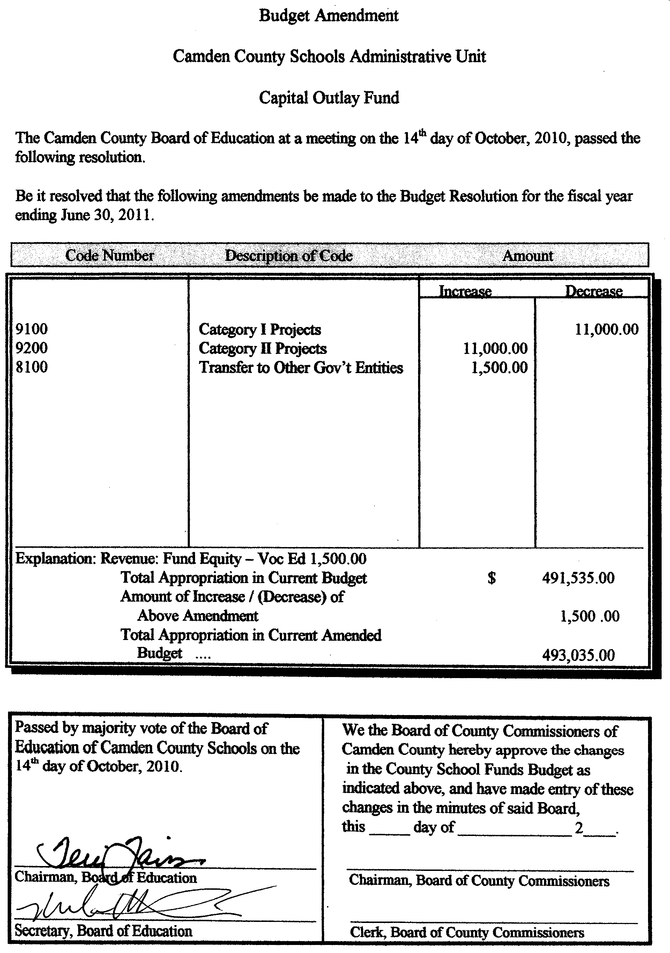
b. Local Current Expense Fund

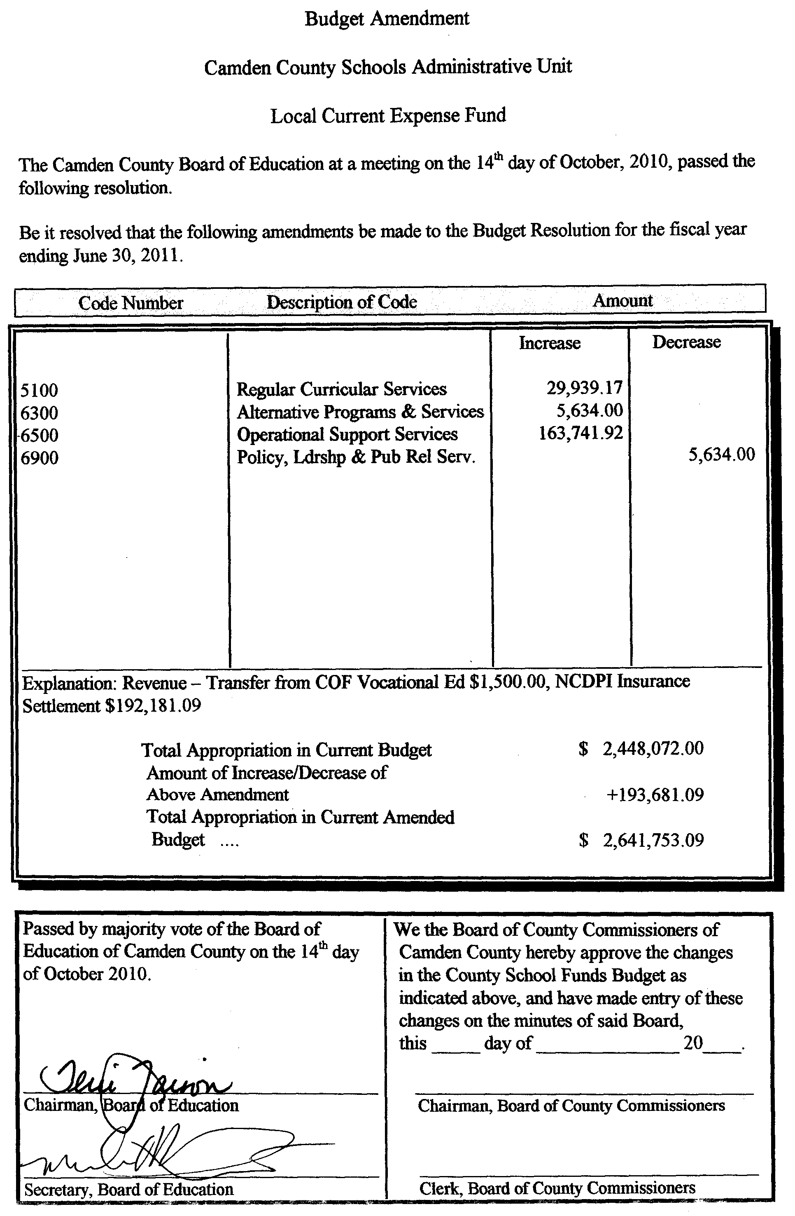

D. Set Public Hearing for Conditional Use Permit (UDO 2010-08-17) Camden Plantation PUD Master Plan - Set Public Hearing for November 15, 2010

E. Tax Refunds, Pickups, & Releases

Name Amount Type Reason No.
Williams Farms $877.15 Adjustment Adjustment 12872
Kevin Old -$121.27 Adjustment Adjustment 12860
John E. Jerebee Farming Inc $864.18 Adjustment Value Adjustment 12886
TR Tarkington Jr. $148.17 Adjustment Adjustment 12866
George Wood Farms -$230.72 Adjustment Adjustment 12847
Old Mill Farm $178.23 Adjustment Adjustment 12859
K & G Farming Inc. $587.00 Adjustment Adjustment 12854
Shelby Mansfield -$440.51 Adjustment Adjustment 12856
Calvin Mercer +$135.94 Adjustment Adjustment 12858
K & A Farms -$161.96 Adjustment Adjustment 12851
Wade Allan Nevins $164.58 Pick Up Listed in Currituck County 12869

New Business

New Business
Item 5. A. Presentation: Follow-up to Youth 4-H Trip to National Junior Horticulture Association Annual Competition in Cleveland Ohio on October 7-12, 2010.

Danielle Barco, of the Camden County Cooperative Extension Service, gave a brief introduction to this agenda item:
- On October 4th, the 4-H Horticulture Team from Camden County came before the Board to seek support for their trip to the Annual Competition in Cleveland Ohio, which they attended on October 7-12, 2010.
- They achieved many honors at the competition
- Ms. Barco showed a slide show depicting the students at the competition, and some of the many horticulture items they had to identify in the course of their competition.
- Adam Lannon, one of the 4-H team members, is here to speak about the trip

At this point, Adam Lannon spoke and gave a brief run down of some of the awards earned by the Camden County team:
- The Camden County 4-H team competed in the performing arts, and achieved first place nationally.
- In the Artist Design competition, Kayla Murphy and Sarah Bond were national winners
- In the Extempore Speech competition, Sully Goetz was a national winner
- Andy Bond was the Grand National Winner of the Illustrated Talk Competition
- In the IDE Competition, the Camden County 4-H team came in 5th place nationally, (I - Adam Lannon - did not compete in the team competition here, I competed in individuals and came in 3rd place nationally.)
- On awards night, “Camden County” was heard many times

Danielle Barco thanked Ms. Darlene Lannon for being the coach for the 4-H Horticulture Team, and for her efforts with these amazing young people.

Chairman Faison thanked them and said how proud Camden is of their achievements.

Commissioner’s Report

Commissioner Michael McLain had the following to report:
- Veteran’s Day Flag Raising Ceremony on November 11, 2010, begins at 7:30 AM

County Manager’s Report

County Manager, Randell Woodruff had the following items to report:
- Reviewed schedule for Board of Commissioners Annual Organizational meeting:
  - Start at 8:00 AM with Swearing In of New Commissioners, Election of Chair and Vice Chair, and Appointment of Clerk and Attorney
  - Go directly into Board of Commissioners meeting by 8:15 or 8:20, hope to conclude by 11:00 AM
  - Reconvene at Camden Intermediate School for a Joint Meeting with the Board of Education to start at 11:30, including a lunch; hope to conclude by 2:30 PM
- We have been included in the Federal Presidential Declaration to assist the residents of the Bunker Hill area of the South Mills Township. We received notification that Camden County has been added to the list of Presidential declared counties for Tropical Storm Nicole for individual assistance.
- On Friday, November 12, 2010, at 10:00 AM, there will be a dedication at the Dismal Swamp State Park for their new board walk.
- We have received a request for funding support from Students Against Destructive Decisions (SADD) at Camden High School. Three members of this group have come and met with me last Friday morning. There is a group from the High School that will be going later this month to a SADD State Conference in Raleigh for three days. These three students have asked for a donation to offset their expenses in connection with this conference.

At 7:20 P.M., Commissioner Michael McLain made a motion to recess the November 1, 2010 Camden County Board of Commissioners meeting for the purposes of convening the South Camden Water and Sewer District Board of Directors meeting. The motion passed with Chairman Phil Faison, Vice-Chairman Sandra J. Duckwall, Commissioners Melvin Jeralds, Garry Meiggs, and Michael McLain voting aye; no Commissioner voting no; no Commissioner absent; and no Commissioner not voting.

At 7:25 P.M., Commissioner Garry Meiggs made a motion to adjourn the South Camden Water and Sewer District Board of Directors meeting and reconvene the Camden County Board of Commissioners meeting. The motion passed with Chairman Phil Faison, Vice-Chairman Sandra J. Duckwall, Commissioners Melvin Jeralds, Garry Meiggs, and Michael McLain voting aye; no Commissioner voting no; no Commissioner absent; and no Commissioner not voting.

Information from Board and Staff

None

Meeting Adjourned

At 7:26 P.M., Chairman Phil Faison asked if there were any other matters to come before the Board of Commissioners, hearing none, he called for a motion to adjourn the meeting.

Commissioner Michael McLain made a motion to adjourn the November 1, 2010 Board of Commissioners meeting. The motion passed 5-0 with Chairman Phil Faison, Vice-Chairman Sandra J. Duckwall, Commissioners Melvin Jeralds, Garry Meiggs, and Michael McLain voting aye; no Commissioner voting no; no Commissioner absent; and no Commissioner not voting.

The meeting was adjourned at 7:26 P.M.

Chairman Phil Faison
Camden County Board of Commissioners
ATTEST:

Amy D. Barnett
Interim Clerk to the Board

