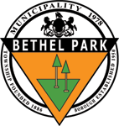
BETHEL PARK SHADE TREE COMMISSION AGENDA

Wednesday April 15th, 2026; 6:30 PM
- Roll Call

- Approval of Minutes – Previous meeting date

- Old Business
  - Update on Grants and Deadlines
  - Arbor Day 2026 plans - Molly Hill Park
  - Memorial Day Parade Activity

- New Business
  - Community Day Activity – Pre Plan

- Future Meeting Dates
  - August 12, 2026
  - November 18, 2026

- Adjournment

